CT Baseball - Coaches Practice Playbook – Practice 12
Coaches Reminder – In addition to this practice plan, refer to the CT Baseball drill library to help customize based on the skill level of your team and desired focus areas.
Pre-Practice Huddle (5 minutes):
- Rule review – Hit by pitch. Normally if a ball hits a batter, they get to go to first base. If the ball bounces and hits the player, it’s still a hit by pitch and the player gets first base. If the pitch hits his hand but he doesn’t swing, it’s a hit by pitch. If a player swings/offers and it hits his body, it’s a strike. If a player ducks into the strike zone and is hit in the strike zone, it’s a strike. Ok to share this with younger players, but usually the coach won’t hit them!
- Discuss what went well/not so well in recent games/practices
Warm Up/Partner Skill Building (20-25 minutes):
- Follow the CT Baseball – Suggested Warm Up Routine guidelines
Stations (30-40 minutes):
- Divide players equally into groups – suggest 3-4 stations total depending on the number of assistant coaches/parent helpers. You can also split the team into two groups and change the stations after two rotations (for a total of 4 stations).
- Station 1 – Hitting - Suggested Drill – Offset Open/Closed (Medium): Have the hitter begin with their front foot very open or very closed. Do not stride, but rotate with good swing depth and direction, while coiling on the back hip and maintaining posture. Offset open will be better for players struggling with hitting the ball the opposite way, while offset closed will help with players struggling to the pull side.
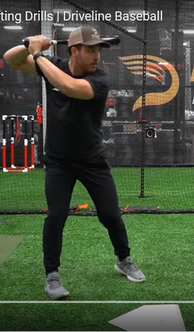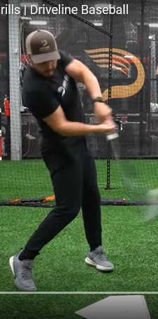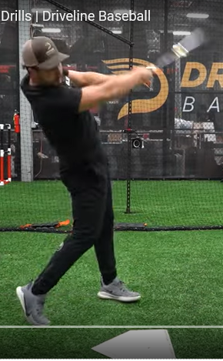
- Station 2 – Infield - Suggested Drill – Short Hops (Easy): Divide players into pairs with the partners about 15 feet apart. Begin with players on their knees and gloves on. One partner is each pair has a glove. Partners throw the balls back and forth, with the throws short hopping to their partner on one bounce. To add a competitive element, you can have the players count when they miss a scoop. Players are eliminated when they get to 5 misses. As players advance, this drill can also be done standing up, to simulate a first basemen or infielder scooping a live ball.
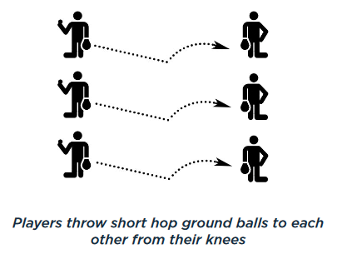
- Station 3 – Outfield - Suggested Drill – Wide Receiver (Easy): The coach lines up as a quarterback with a bucket of balls and a line of players 10-20 feet to their left. On the coach’s signal, the players sprint downfield and then turn in on a 45 degree angle to make a “post” pattern. Just after the turn, the coach will throw a fly ball to the player. After the player complete their attempt, they line up on the other side of the coach. Once all players are done on the left side, the coach will throw post patterns with the players coming from the right side. The drill is complete when all players have gone on both sides. You can make this drill easier or harder by having the patterns closer or further away.
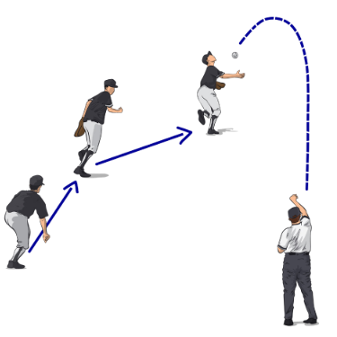
Station 4 - (Optional) Pitching - Front Screen/Fence Drill (Easy): The purpose of this drill is to eliminate excessive movement in the throwing arm and legs, and encourage striding directly toward the plate. With the pitcher on the rubber, set the screen (or fence) roughly 6-12 inches from the pitchers toes. The focus is for the pitcher not to contact the fence when working through their stretch or windup.
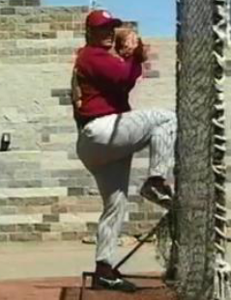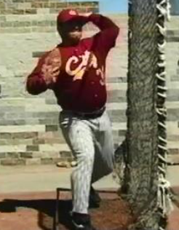
- Players will spend about 10 minutes at each station before rotating to the next
Water Break + Huddle (5-10 Minutes):
- Word of the Week – Toughness
  - “Most people succeed because they are determined to.”
  - The road to greatness is not marked by perfection, but the ability to constantly fail, learn and improve.
  - Tough times don’t last, tough people do.
  - Tough teams aren’t discouraged by a loss or a mistake or by being behind on the score board.
  - Team Building Activity of the Week – “Show how tough you are – let’s arm wrestle!” Have the kids square off in an arm wrestling tournament and see which player wins. Alternatively, have a thumb wrestling tournament.
- Team Activity (25-30 Minutes):
Suggested Drill - 3 Team Scrimmage (Easy): Divide teams into three groups (some groups can have 4 if needed). One group is infield, one is outfield, one is at-bat. The coach’s will act as pitcher (and catcher, if needed). The coach will pitch to the first team at bat. The infield and outfield will try to get the hitters out. The game continues until 3 outs are made (or the hitting team bats 2-3 times through). No bunting, and this is a good chance to stop the game and coach, as needed.
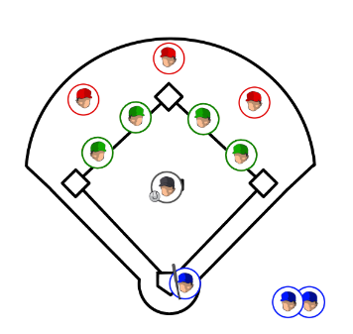
Fun Activity – Have players choose their favorite activity from the year and repeat it. Options include relay races, bucket toss, laser show, long distance challenges, etc.
Post Game (2 minutes):
- Remind players of next upcoming practice and any details regarding schedule
- Encourage teammates to practice at home with parents, guardians or friends
- If this is the last practice, remind players of how much the season meant to you, and how much fun you’ve had being their coach, encourage them to sign up for fall/spring baseball to continue playing!

