CT Baseball - Coaches Practice Playbook – Practice 1
Coaches Reminder – Always write down what you’re planning to do prior to running a practice. This will keep the practice organized and focused. There is nothing worse than kids waiting around for coaches to decide what to do next! In addition to this practice plan, refer to the CT Baseball drill library to help customize based on the skill level of your team and desired focus areas.
Pre-Practice Huddle (5 minutes):
- Greet Players, introduce the Coaches
- Have players introduce themselves
- Reminders – Be on time, try your best, pay attention during instructions
- Ask players to run to various positions on the field, the foul lines, the fence, the dug out, the batters box and the coaches boxes (for young teams, explain what each one is)
Warm Up/Partner Skill Building (20-25 minutes):
- Follow the CT Baseball – Suggested Warm Up Routine guidelines
Stations (30-40 minutes):
- Stations are generally more productive than full team drills in youth baseball because attention spans are short in young athletes. Stations allow athletes to participate more, stack repetitions and minimize time standing around or engaging in horseplay with teammates.
- Divide players equally into groups – suggest 3-4 stations total depending on the number of assistant coaches/parent helpers. You can also split the team into two groups and change the stations after two rotations (for a total of 4 stations).
- Station 1 – Running - Suggested Drill – Swing and Sprint (Easy): Line up your players at home plate in the batters box. Have each player simulate swinging, dropping the bat, then exploding to first base. Run all the way through first and into foul territory. You can time this to add a competitive element.
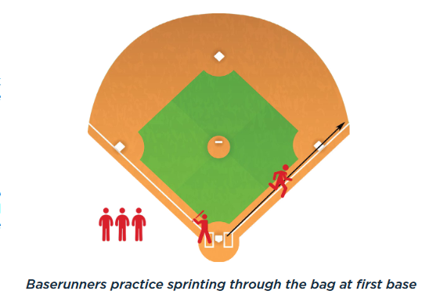
- Station 2 – Infield - Suggested Drill – Grounder Goalie (Easy): Create a “goal” with two cones spaced about 10 feet apart. One player stands as a goalie between the cones with a glove on. Other players make a line. Either have a player back up the goalie or make the goal against a fence. The coach throws or hits grounders towards the goal with the goalie trying to keep the ball out of the goal. The goalie should make three stops (field 3 balls) before moving to the back of the line. This can also be played as a “knockout” game where a player is “out” if they let the ball behind them.
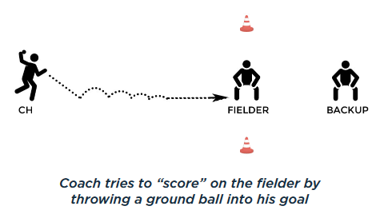
- Station 3 – Hitting - Suggested Drill – Double tee (Easy): Set up 2 tees, one on the front of the plate and one on the point (back) of the plate. Set a ball on the tee on the front of the plate. Try to hit the ball off the front tee without hitting the tee that is in the back. This should keep your bat level through the zone and create backspin.
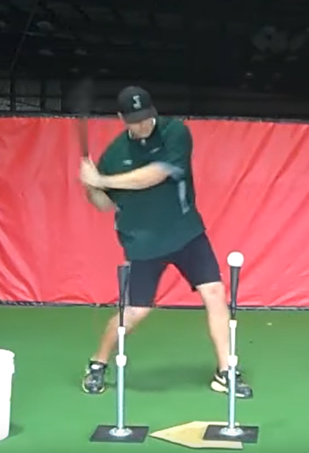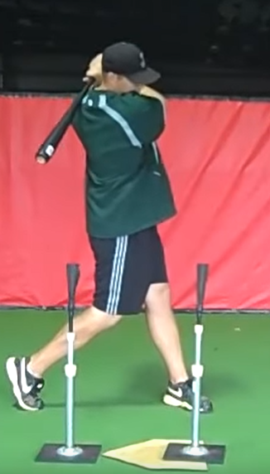
Station 4 - (Optional) Pitching/Throwing - Suggested Drill – Balance, Power, Finish (Easy): The purpose of this drill is to establish balance at three crucial stages of the delivery. This drill is typically done with partners, gloves on, and a baseball for each set of partners. Have the pitchers begin by lifting their stride leg and balancing with their leg up for several seconds. Coaches can even gently push the players leg and see if they can maintain their balance. Next, have the player separate their hands and stride, with throwing arm back and glove hand tucked, pointed towards the target in the power position. Have the player pause in the power position and check for balance and arm/leg position. Finally, have the player finish their delivery in a follow through, with balance on their stride foot and prepared to field the baseball. Note that pitchers that throw with good velocity tend to “fly open” and spin off towards first base (right hander) or third base (left hander). This is acceptable and necessary to generate velocity, but for many youth pitchers it’s important to teach balance to improve thrown accuracy and provides the pitcher with the ability to protect themselves when a ball is hit to them.
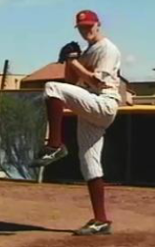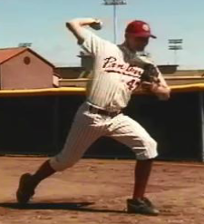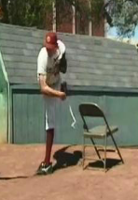
- Players will spend about 10 minutes at each station before rotating to the next
Water Break + Huddle (5-10 Minutes):
- Word of the Week – Teamwork
  - Teamwork is the process of working together with a group of people in order to achieve a goal
  - Oftentimes, in order for you to succeed in life and achieve big goals, you need to work together with friends, families, teams, groups or organizations. More people have more power.
  - We will need to work together to succeed on the baseball field – so let’s get to know everyone on the team!
- Team Building Activity of the Week - Have each team member tell the team one interesting fact about themselves
Team Activity (25-30 Minutes):
Suggested Drill - 3 Team Scrimmage (Easy): Divide teams into three groups (some groups can have 4 if needed). One group is infield, one is outfield, one is at-bat. The coach’s will act as pitcher (and catcher, if needed). The coach will pitch to the first team at bat. The infield and outfield will try to get the hitters out. The game continues until 3 outs are made (or the hitting team bats 2-3 times through). No bunting, and this is a good chance to stop the game and coach, as needed.
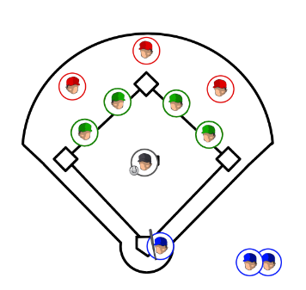

Fun Activity (5 Minutes):
- Set a Ball on a Tee – Player to hit the ball the furthest is the winner and gets to choose 1 player and 1 coach to run to center field and back together
Post Game (2 minutes):
- Remind players of next upcoming practice and any details regarding schedule and uniform distribution
- Encourage teammates to practice at home with parents, guardians or friends

