CT Baseball - Coaches Practice Playbook – Practice 6
Coaches Reminder – In addition to this practice plan, refer to the CT Baseball drill library to help customize based on the skill level of your team and desired focus areas.
Pre-Practice Huddle (5 minutes):
- Rule review – Running lane review - A runner from home to first has a lane from the foul line to 3 feet outside the foul line half way down the line. If they have one foot completely inside the line or completely outside, they can be called for interference on the catch if a throw is made and the throw is accurate. Usually happens on a bunt or tapper that the catcher fields and the throw hits the runner in fair territory. This also applies to third base, but it’s a lot less common (pickoff throw from catcher or run down situation).
- Discuss what went well/not so well in recent games/practices
Warm Up/Partner Skill Building (20-25 minutes):
- Follow the CT Baseball – Suggested Warm Up Routine guidelines
Stations (30-40 minutes):
- Divide players equally into groups – suggest 3-4 stations total depending on the number of assistant coaches/parent helpers. You can also split the team into two groups and change the stations after two rotations (for a total of 4 stations).
- Station 1 – Hitting - Suggested Drill – Knob to Knee Drill (Hard): This drill emphasizes getting the front (stride) foot down before triggering the hips and hands. Notice that the left knee rises across to the right shoulder, creating torque. Use a tee for this drill.
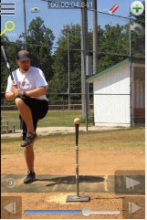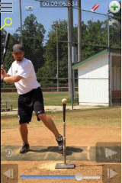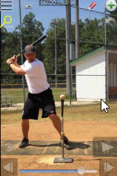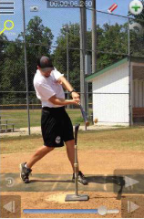
- Station 2 – Infield - Suggested Drill – Center, Left, Right (Medium): The coach will line players up about 10-15 feet away in the infield. Players will receive 3 ground balls from the coach in quick succession. One ball will be in the center of their body, one slightly to their left, one slightly to their right. The objective is to teach the footwork for center, forehand, and back hand pickups. After fielding, the player will gather the ball like they’re ready to throw, but then flip the ball back to the coach softly. On the forehand, the player should drop their glove side foot to angle towards the baseball. On the backhand, the arm side foot should drop. Full cross over backhand should only be used in emergency situations (i.e. diving).
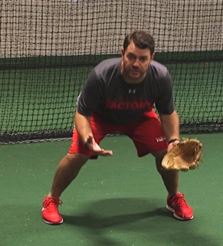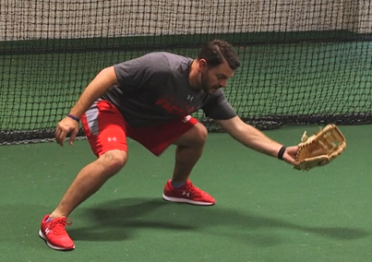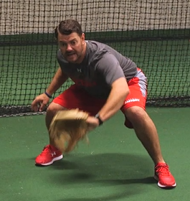
- Station 3 – Outfield - Suggested Drill – MINE (Easy): This drill is to practice common communication between fielders. Coach stands 5 feet behind second base with a bucket of balls. Place outfielders in two lines in right center and left center. All players should have a glove. Coach throws a high pop fly between the outfielders. The player closest to the ball should shout “Mine Mine Mine!” The other player should move to back up. Both players go to the back of the line and the drill begins again with the next player.
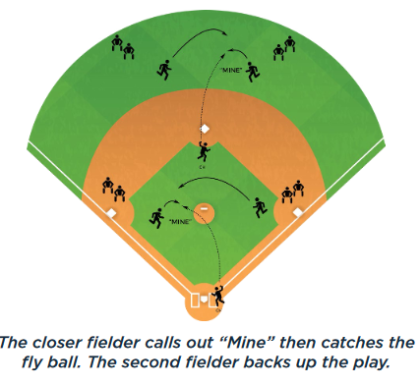
Station 4 - (Optional) Pitching/Throwing - Suggested Drill – Rocker Throws (Medium): This drill emphasizes front side brace and long, powerful stride length. Start the drill with feet at full stride length and front foot slightly closed from the target. Rock back and forth and then throw the ball to the target, finish by bringing back leg through and following through. Rotate around a braced (not flexed) front leg. This drill can be done with a partner, or against a fence.
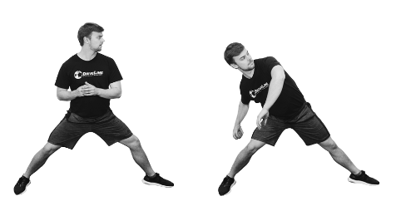
- Players will spend about 10 minutes at each station before rotating to the next
Water Break + Huddle (5-10 Minutes):
- Word of the Week – Accountability
  - "The most important quality I look for in a player is accountability. You've got to be accountable for who you are. It's too easy to blame things on someone else." Lenny Wilkins
  - Accountability is understanding that sometimes we make mistakes, and it’s not fair to blame others or the environment for those mistakes
  - Accountability is being unwilling to quit and having determination to find a solution, even when the first few tries don’t work
  - Champions hold themselves accountable to their performance and their attitude, everyday
  - Team Building Activity of the Week – Play a game of tag (within the infield). Explain after the game is over, that being accountable is understanding if you want to get better at tag, you could do agility drills, run a lot, and play tag more often to get better at it, instead of blaming others for the loss.
- Team Activity (25-30 Minutes):
Suggested Drill - Pressure Hitting (Medium): This is a great drill to encourage making contact and driving the ball under pressure. Have the coach line up at the pitcher’s mound with a bucket of balls, one player in the batters box and the rest of the team in a line, ready to run. The coach pitches to the batter. The batter must swing no matter what. If the batter makes contact, the next batter steps up and the player that just hit returns to the sprinters line. If the batter misses, everyone must sprint to the outfield fence! If there’s a foul ball, the batter gets another chance. You can also use jumping jacks, sit ups or push ups. You can increase difficulty by only counting hits into the outfield (infield hits are foul balls). You can make it easier for young teams by giving 3 strikes.
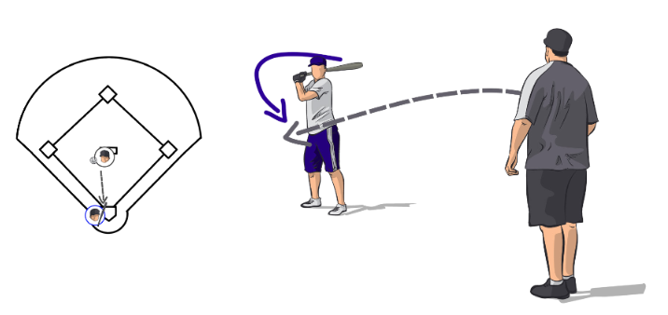
Fun Activity – Long Throw Challenge – Have players stand at home plate and attempt to throw the ball as far as they can. The player that throws it the furthest gets to choose a coach to run to the fence and back.
Post Game (2 minutes):
- Remind players of next upcoming practice and any details regarding schedule and uniform distribution
- Encourage teammates to practice at home with parents, guardians or friends

