CT Baseball - Coaches Practice Playbook – Practice 7

Coaches Reminder – In addition to this practice plan, refer to the CT Baseball drill library to help customize based on the skill level of your team and desired focus areas.

Pre-Practice Huddle (5 minutes):

* Rule review – Over Running First Base - The runner is allowed to overrun first base and can even be slightly inside the foul line when overrunning. The moment he makes an “attempt” towards second, he’s fair game to be tagged out, as he’s now trying to go to second base.
* Discuss what went well/not so well in recent games/practices

Warm Up/Partner Skill Building (20-25 minutes):

* Follow the CT Baseball – Suggested Warm Up Routine guidelines

Stations (30-40 minutes):

* Divide players equally into groups – suggest 3-4 stations total depending on the number of assistant coaches/parent helpers. You can also split the team into two groups and change the stations after two rotations (for a total of 4 stations).
* Station 1 – Hitting - Suggested Drill – Off-Set Front Toss (Medium): Set up pretty far back from the hitter, diagonal and inside from their front hip. Use a tee ball, plyoball, or whiffle ball if you don’t have a screen. Objective – let the ball get deep in the strike zone and have the batter hit to the opposite field (stay closed).

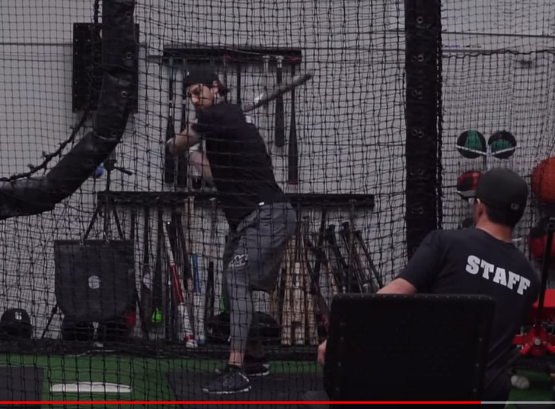

* Station 2 – Infield - Suggested Drill – Barehand Throwing Gauntlet (Medium): This drill is used to practice executing a quick pivot in both directions after fielding a ball, and to ensure balls that are not moving are picked up with their bare hand. Line up 4 balls in a straight line, leaving 5 feet of space between each ball. Position “Catchers” about 15 feet from each ball (as shown). When the coach says “go” the runner will pick up each ball and throw to the appropriate catcher. As soon as the ball is caught, the catcher will put the ball back in place in the running line. After the first runner/thrower completes the gauntlet, the coach can send the next player. Rotate the runner/thrower and catchers after each completion. You can make this a competition by timing the drill, or completing as a race between two teams.

* Station 3 – Outfield - Suggested Drill – Drop Step Drill (Medium): This drill is to practice moving backwards on pop flies and line drives. Create a line of fielders (with gloves) standing 20 feet from the coach. The first fielder should be in ready position, looking at the coach. The coach throws the ball, and the fielder uses a drop step to move back to catch the ball. The fielder should catch and smoothly transition to throwing the ball back to the coach. The drill begins again with the next player. Be sure to demonstrate the drop step footwork for younger players before beginning. To start, you can concentrate on dropping to only one side at a time to make it easier for young players to repeat correctly.

* Station 4 - (Optional) Catcher - Suggested Drill – Dirt Balls (Medium): Set catchers in their stance with gloves on. From 5-10 feet away, toss the ball into the dirt in front of the catcher. The catcher should quickly lower himself onto his knees to block the ball. Try mixing it up by throwing dirt balls to the left, right and middle of the catcher. As the catcher gets the technique down, put on full equipment and begin throwing dirt balls from a longer range.
* Replace your feet with your knees in one, fluid motion
* Drive your knees into the ground where your feet were (about shoulder-width apart, with your upper body centered between them.
* So that you can get to your knees easier, clear away your feet by sliding them out to the side of your body.
* Keep your shins on the ground and your toes pointed back and away from you to be in the best position to block the ball.
* As you see the ball approaching the dirt, drop your mitt between your legs. The web of your mitt should be in contact with the ground, and the palm of your glove should be squared towards the pitch. Your fingers will be below the ball.
* Tuck your arms: As you drop your glove, keep your throwing hand poised above the mitt or tight to your throwing-side. Your glove-side arm should be tight to your body, making a larger blocking area.
* Your upper body should be straightened and angled forward, over the ball. By doing this, you can knock down the ball and deflect it straight into the ground, rather than away from you.
* Tuck your chin and always watch the ball.
* Players will spend about 10 minutes at each station before rotating to the next

Water Break + Huddle (5-10 Minutes):

* Word of the Week – Body Language
  + Body Language is how we project our feelings through actions, gestures and posture
  + Even if you don’t always feel your best, you need to “fake it until you make it”
  + Your teammates follow your lead – if one player is angry, sad, annoyed or frustrated, it impacts the whole team
  + Champions keep their heads up, shoulders back and stay tall, no matter what’s going on in the field
  + Team Building Activity of the Week – Play Charades – see how much you can communicate just with body language!
* Team Activity (25-30 Minutes):

Suggested Drill - 3 Team Scrimmage (Easy): Divide teams into three groups (some groups can have 4 if needed). One group is infield, one is outfield, one is at-bat. The coach’s will act as pitcher (and catcher, if needed). The coach will pitch to the first team at bat. The infield and outfield will try to get the hitters out. The game continues until 3 outs are made (or the hitting team bats 2-3 times through). No bunting, and this is a good chance to stop the game and coach, as needed.

Fun Activity – Relay Race – Divide teams equally in speed/athleticism. Have half of the team line up at second base, and the other half line up at home plate. When the coach says go, the first player in each line will sprint all the way around the bases. Once the player makes a complete circuit (either from second back to second, or home to home) the next player in line runs the bases. The race continues until all players complete their circuits. The winner is the team that rounds all of the bases first!

Post Game (2 minutes):

* Remind players of next upcoming practice and any details regarding schedule
* Encourage teammates to practice at home with parents, guardians or friends