**Center Township – Field Maintenance Guide:**

Daily Maintenance:

* Fill in any holes that developed during play, including the pitchers mound and batter boxes. This can be done with a hand rake or shovel.
* Fix sliding paths for bases by pushing dirt from behind the base back towards the front of the base. This should be done with a hand rake.
* Drag the field within the baselines. Each time you drag, start in a new spot on the infield (see X’s below) and go in opposite directions (clockwise vs counter clockwise). It’s best to drag with the base plugs in and drag directly over the plugs in order to avoid a mound at each base. This avoids the buildup of infield mix over time.

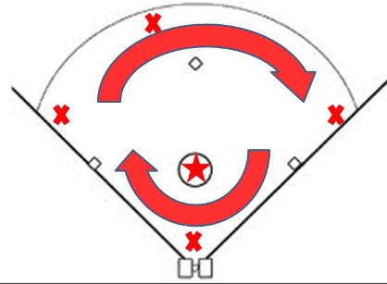

* Drag the outer edge of the bases and foul territory separately (make a final circle around the outside), as they are on different grades. Do not drag within 2 feet of the grass edge. This helps to promote water runoff.
* Generally, the mat drag (square interlinked steel drag net) on a tractor is the best tool to drag the field. If the field is extremely dry/dusty, a nail drag followed by the mat drag can be beneficial. The nail drag should only be used after we’ve had some rain, or it won’t penetrate.
* You can also use a mat drag as a hand drag to even out problem spots quickly without getting the tractor out.
* The home team is primarily responsible for maintaining the playing surface before and after the games, including chalking lines, putting bases down/up and dragging the field.
* The visiting team is responsible for emptying trash cans after the game.
* Each team is responsible for cleaning out their dugout at the end of the game.

Prior to Rain:

* Maintain the playing surface vigilantly per above directions.
* Pack the field tight by using a roller. Hard packed dirt runs the water off, while drag marks tend to catch the rain on the playing surface.
* Cover the mounds with tarps to avoid saturation and deterioration of the mound lip.

After Rain:

* Agitate the dirt from the soaked up puddle to promote absorption
* Use Field Dry to finish soaking up water – try to limit to less than two bags
* Limit the use of a broom to push water into the outfield – this moves dirt and changes the grade, preventing water run off over time. You’re better off pushing it into the infield into a drier spot.
* Do not remove muddy infield mix from the field
* Use a rake or nail drag to loosen the infield mix so it will dry more quickly

Grass Cutting:

* Grass should be cut every week (two weeks maximum in the heart of summer)
* Spring and Fall grass should be 2”, summer is 3”
* Each League group needs to cut their own fields – Field Maintenance Director is responsible for assigning the task and ensuring upkeep
* When fields are cut regularly
  + Fields 1-3 can be cut in about 30 minutes
  + Field 4 can be cut in about 45 minutes
  + Field 5 can be cut in about 60 minutes

Equipment:

* The majority of the equipment is stored in the main shed by the concession stand, including:
  + Large John Deere Tractor – Diesel powered, heavy implement used for major field work (turning over infields). Has aggressive tires and cannot be used on duraedge fields.
  + Ferris 60” Zero Turn – Gasoline powered, used for cutting grass and dragging fields.
* There is equipment in the lower shed (between Mustang/Pinto):
  + Small John Deere Zero Turn – Gasoline powered – can be used to cut grass and drag fields.

Equipment Maintenance:

* Before running any of the equipment, check the oil and top off if necessary
* Before running any of the equipment, fill with fuel (John Deere is diesel, remainder are gas)
* Brush excess grass off of the mower decks before parking
* Scrape off dirt built up from rakes or plates before parking
* Equipment needs to be serviced (oil change, filter change, plugs, blades sharpened) annually - usually in the late winter or very early spring
* Contact one of the field maintenance directors if the gasoline or diesel fuel cans are low

Bases:

* Prior to each game, remove the base plugs and put them in the field’s maintenance shed
* Prior to each game, take the bases out of the field’s maintenance shed and drop them into the boxes in the ground
* When the base is installed correctly, all corners and sides should sit flush with the ground
* If the ground mount is no longer level, inform the Field Maintenance Director to address the situation with field repairs
* After each game, put the bases back in the maintenance shed, install the plugs, and drag the field

Chalking Lines:

* Place the steel Homeplate chalk template down on top of Homeplate. The template can usually be found behind home plate or in the field maintenance shed. If you cannot locate the template, you may need to free hand the batters box by using the prior lines as a guide.

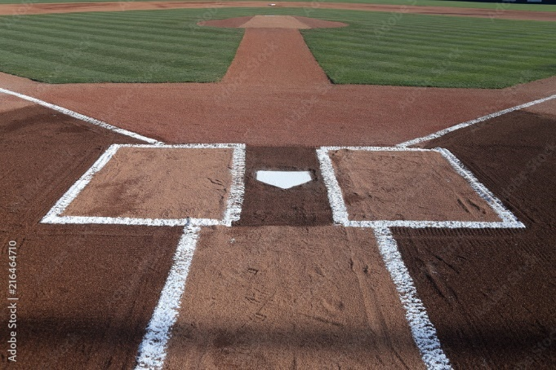

* The wheeled chalking tool can be found in each fields maintenance shed. You will usually need to load at least one bag of chalk from the shed into the tool to finish the job.
* Chalk the batters boxes using the template on each side
* Next, in order to obtain straight foul lines, use the string lining tool found in each equipment shed for each field.
* Hammer in the nail directly behind the apex (point facing towards the catcher) of home plate and run the string to the outfield foul poles. The line should run such that the outside edge of first/third base lines up with the string. The chalk needs to end up completely under the base! You may need to tighten or slightly adjust the string line if it does not align.

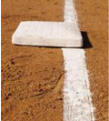

* Don’t chalk the inside of the batters box, first base or third base, but otherwise run the wheeled chalk tool down the string all the way to the foul pole
* If the outfield lines remain visible or time is running out, you may choose to only finish the infield chalk
* For coach pitch (especially tournaments or playoffs), have an assistant hold the string on the pitchers rubber. Unwind the string so that you have ~5 feet of string, with the nail on the outside. Use the nail to mark a 10 foot diameter circle around the pitching rubber. Use the wheeled chalking tool to mark the pitchers mound. Note that the Mustang field is a little long, so you will want to place a line for the coach pitchers to pitch from that is inside the pitching mound radius, 38 feet from the back of home plate.
* For coach pitch (especially tournaments or playoffs), mark a line exactly half way between first and second, second and third, and third and home plate. This determines when runners advance/go back for that age group.
* For coach pitch (especially tournaments or playoffs), use the nail to trace a 5 foot diameter arc from foul line to foul line in front of home plate. This is a foul ball off of a hit ball for that age group.