CT Baseball - Coaches Practice Playbook – Practice 3
Coaches Reminder – In addition to this practice plan, refer to the CT Baseball drill library to help customize based on the skill level of your team and desired focus areas.
Pre-Practice Huddle (5 minutes):
- Rule review – Review what happens when a runner and fielder collide. Fielder attempting to make a play on a batted ball when a runner hits them = interference (runner is out), Fielder gets in the way of a runner not making a play on a batted ball = obstruction (runner is safe and is awarded bases at umpires discretion).
Warm Up/Partner Skill Building (20-25 minutes):
- Follow the CT Baseball – Suggested Warm Up Routine guidelines
Stations (30-40 minutes):
- Divide players equally into groups – suggest 3-4 stations total depending on the number of assistant coaches/parent helpers. You can also split the team into two groups and change the stations after two rotations (for a total of 4 stations).
- Station 1 – Baserunning - Suggested Drill – Baserunning Circuit (Easy): Have players practice making the turns around the bases. You can begin by having them turn just to second like a double. Then have them run all the way around the bases. You can time these with a stop watch to add a competitive element.
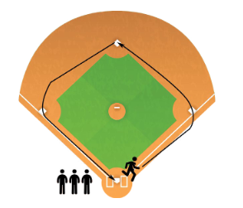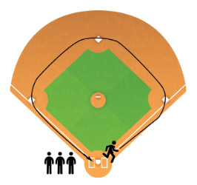
- Station 2 – Infield - Suggested Drill – Ground Ball Faceoff (Easy): This is a high intensity game to get lots of fielding repetitions quickly. Divide team into two single file lines facing each other about 20 feet apart. All players have a glove. On the coach’s signal, the first player (with a ball) throws a grounder to the first player in the other line. After throwing, the player immediately runs to the end of the other line as fast as they can. The player in the receiving line fields the ball and throws a grounder for the next player in the other line. Play continues at a fast pace – field-throw-sprint. This game can be made more competitive by timing it to see how fast the players can get through the full team, or counting errors and awarding a win to the player with the fewest mistakes.
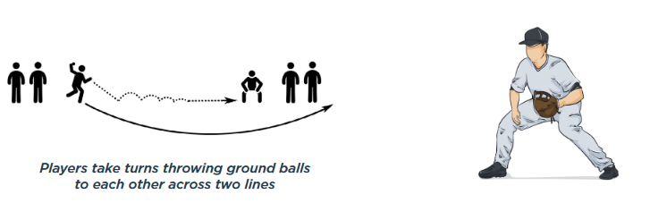
- Station 3 – Hitting - Suggested Drill – Overload/Underload Training (Easy): Swing with a heavier than normal (wooden, Camwood bat, or heavier youth baseball bat) for 10 swings, then swing a very light bat (tee ball, whiffle, or thin bat) for 10 swings. This builds strength, bat speed and adaptability.

- Station 4 - (Optional) Catching - Suggested Drill – Stance (Easy): Have a group of players face the coach with around 5 feet of space between them. You can practice with just a glove. Help the players get in the proper catchers stance – athletic stance with feet slightly wider than shoulder width apart, drop eblows to your knees, point the toes slightly outside, keep knees inside feet, drop lower into the stance into you reach a comfortable position. Throwing hand behind the back or immediately behind the glove. Practice stance for no-runners on (sit on the legs) and runners on (widen legs, come slightly out of your stance, hand behind the glove and ready to throw). Repeat getting into the stance 4-5 times each (runner on, no runners on).
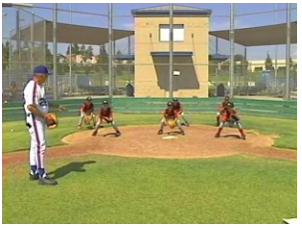
- Step to the ball (Easy): With catchers down in their stance and glove up, have a coach point to the right or left. Catchers will immediately take a short, controlled step in the direction of the point, then move back to middle.
- Catch and Grip (Easy): With catchers down in their stance (runners on), place a ball in each catchers glove. Have the players practice stepping to the ball, rising, stepping forward with the glove side foot, reaching into the glove to grip the ball, cocking the arm back to throw, and then freezing with throwing arm side foot extended and ready to throw.
- Players will spend about 10 minutes at each station before rotating to the next
Water Break + Huddle (5-10 Minutes):
- Word of the Week – Confidence
  - "Confidence comes from being prepared.” John Wooden
  - Confidence is earned. Hard work = improved skills = confidence in how you play
  - Expect to win based on the work you’ve put in
  - Look like a winner – posture, body language, positive self-talk
  - Team Building Activity of the Week – Show and Tell – Show off or tell us something that you’ve practiced so much that you know you’re good at it!
- Team Activity (25-30 Minutes):
Suggested Drill – Doubles (Medium): This drill reinforces the importance of getting the ball back into play quickly on a drive into the outfield. Have 3 or 4 outfielders, a 2nd baseman and a shortstop on defense. Split the team into two groups – fielders and batters. A batter steps up and the coach soft tosses the pitch to the batter (or a tee or normal pitching can be used). The ball is live when the batter hits the ball into the outfield. No matter what, the batter has to attempt to get to second base. The outfielders will relay the ball to second base and try to get the runner out. A coach can hit if players aren’t strong/old enough to consistently hit the ball to the outfield. Emphasize picking up non-rolling balls in the bare hand and turning to the glove side.
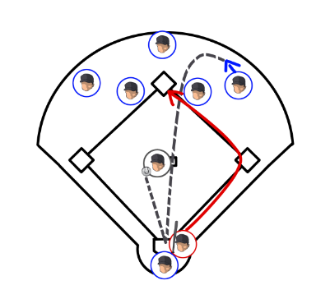
Fun Activity (5 Minutes):
- Coach Knockout – Coach gears up in catchers equipment, sitting in a chair. Players attempt to hit the coach with soft baseballs by hitting the balls off of a tee.
Post Game (2 minutes):
- Remind players of next upcoming practice and any details regarding schedule and uniform distribution
- Encourage teammates to practice at home with parents, guardians or friends

