CT Baseball - Coaches Practice Playbook – Practice 9
Coaches Reminder – In addition to this practice plan, refer to the CT Baseball drill library to help customize based on the skill level of your team and desired focus areas.
Pre-Practice Huddle (5 minutes):
- Rule review – Two runners on the same base. If one of them is tagged, the lead runner is safe and the other runner is out. The following runner is allowed to go back to the previous base if he isn’t tagged.
- Discuss what went well/not so well in recent games/practices
Warm Up/Partner Skill Building (20-25 minutes):
- Follow the CT Baseball – Suggested Warm Up Routine guidelines
Stations (30-40 minutes):
- Divide players equally into groups – suggest 3-4 stations total depending on the number of assistant coaches/parent helpers. You can also split the team into two groups and change the stations after two rotations (for a total of 4 stations).
- Station 1 – Hitting - Suggested Drill – Knob to Knee Drill (Hard): This drill emphasizes getting the front (stride) foot down before triggering the hips and hands. Notice that the left knee rises across to the right shoulder, creating torque. Use a tee for this drill.
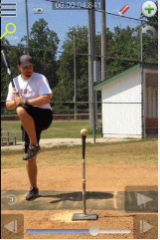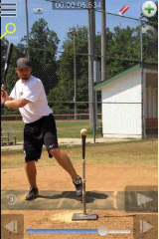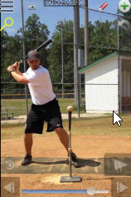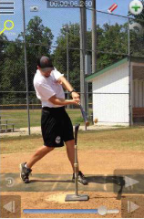
- Station 2 – Infield - Suggested Drill – 3 Cone Drill (Hard): The coach will line players up about 10-15 feet away in the infield. 3 cones will be set up directly in front of the first player in line. The player will start behind the closest cone in a fielding ready position. As the coach rolls the ball, the player will circle to the outside of the second cone, then field in front of the third cone. This drill teaches players to round the baseball with their body weight moving towards first base to make a strong throw. This drill is not hard, but is typically for more advanced players that have solid fielding and throwing fundamentals already established. The drill can be finished with a strong throw back to the coach, or fill up a bucket after each ball is fielded.
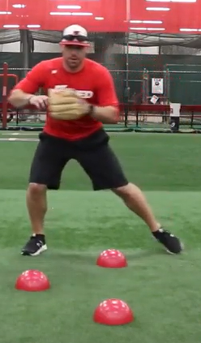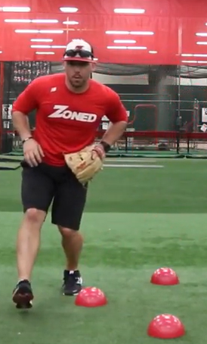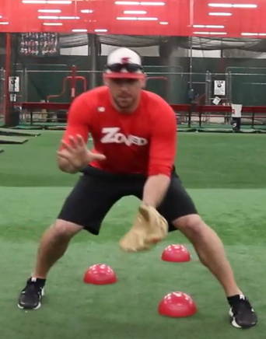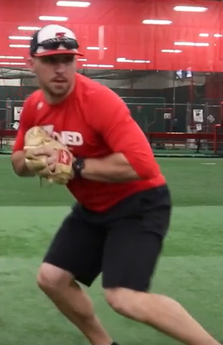

- Station 3 – Outfield - Suggested Drill – Dive Drill (Hard): In the outfield grass, have a fielder kneel about 15 feet away from the coach. Fielder has a glove, coach has a bucket of balls. Coach begins by flipping the ball just outside of the reach of the fielder. Fielder must drive from a kneel to catch the ball. Once the players master this, have them stand up and dive. The coach can get progressively further away as the players gain competence. Even for younger teams, this drill is helpful to encourage them to go all out for the baseball.
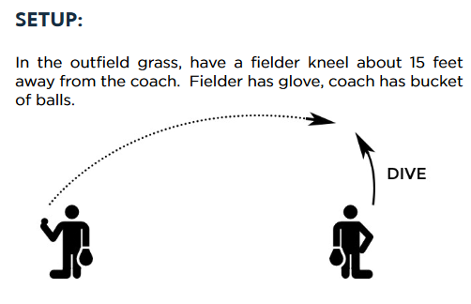
- Station 4 - (Optional) Catching - Suggested Drill – Catcher Volume Throwing (Medium): Place 12 baseballs about 12 inches apart, starting in front of home plate and moving towards the catchers throwing side (usually first base). There should be a player standing at second base to receive throws. Time the catcher and see how fast they can make 12 accurate throws to second base. Alternatively, count how many accurate throws are made out 12 to decide a winner. This drill can be done in full gear or just mask and glove. For young teams, this drill is helpful for building arm strength and accuracy without gear on.
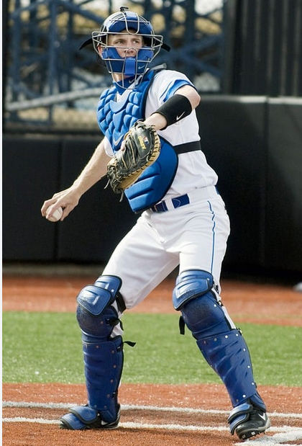
- Players will spend about 10 minutes at each station before rotating to the next
Water Break + Huddle (5-10 Minutes):
- Word of the Week – Resolve
  - It’s not whether you get knocked down, it’s whether you get back up. -Vince Lombardi
  - Getting better takes hard work and a willingness to push through challenges
  - No excuses, no whining, no complaining – all champions are tested with failure but have the resolve to finish anyway. Whining or complaining are complete distractions to the goal.
  - Team Building Activity of the Week – Show your resolve to get back up by starting on your belly and having a race against your teammates!
- Team Activity (25-30 Minutes):
Suggested Drill - Trash Can Relay (Medium): Divide players into two teams. Position one player in left center, another at shortstop. The second team will have players in right center and second base positions. The coach will start by hitting or throwing a ball into the outfield for the left field team. The outfielder will relay to the shortstop, then throw home to a trash can (or other available) target. The team gets a point if the relay throw hits the target. The infielder will rotate to the back of the line, and the outfielder will rotate to the infield position. Immediately after the left field team is done, begin the drill again with the coach hitting to the right field team. End the game after a set number of target hits or a set time. Emphasize with this drill that dead balls against the fence need to be picked up in the bare hand, and the player needs to turn to their glove side to get the ball in fast.
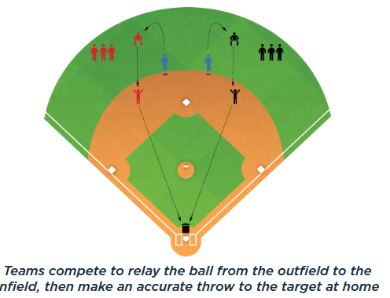
Fun Activity – Laser Show: A coach throws one pitch to each player. The player attempts to hit the ball as hard as they can. The team votes on who hit the best “laser beam” after everyone has hit.
Post Game (2 minutes):
- Remind players of next upcoming practice and any details regarding schedule
- Encourage teammates to practice at home with parents, guardians or friends

