Center Township – Water Supply On/Off Guide:
Overview:
- The water supply is a well head located under a concrete paver about 40 feet down the hill from the concession stand, somewhat close to the staircase between fields 1 and 2.
- The supply has to be turned on in the Spring (before the concession stand opens) and off in the Fall (after the concession stand closes for the season). If the supply isn’t turned off, water will freeze in the pipes and appliances.
- This guide shows the process to turn “off” the supply. Turning it “on” includes all of the same steps, except backwards.

Step 1: Turn off the breaker to the well pump. The breaker is in the main electrical panel, in the main maintenance garage, just inside the garage door. The breaker is marked “pump” on the left hand side.

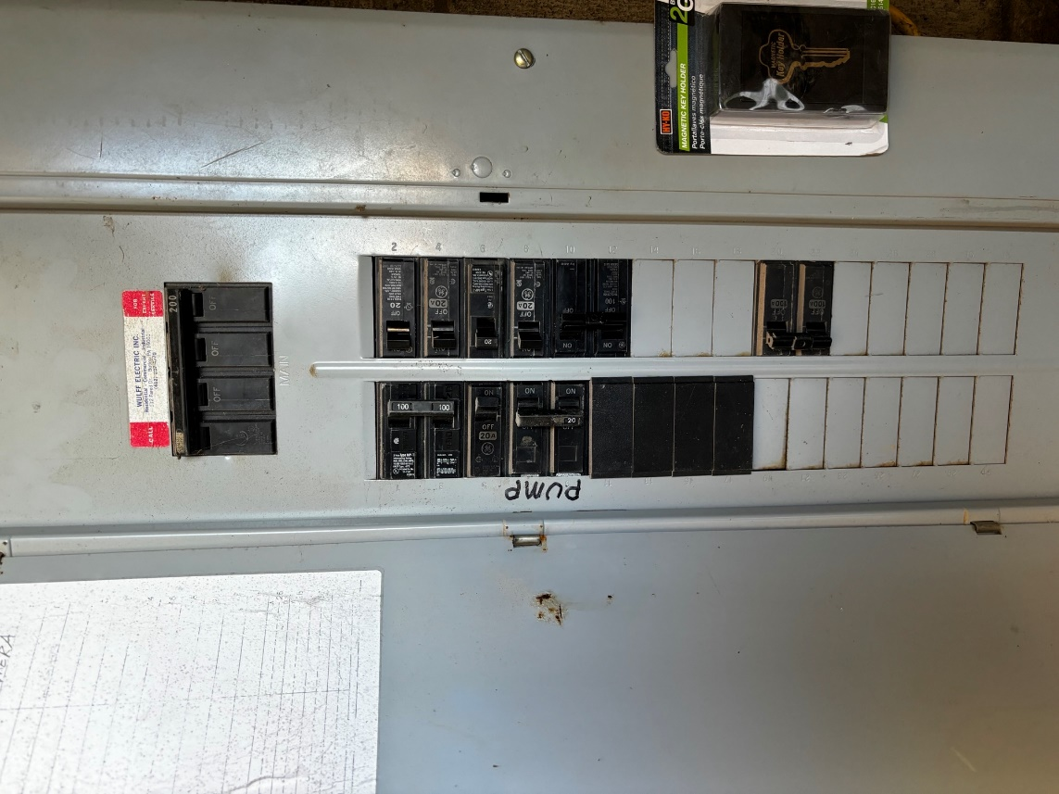

Step 2: Open all water lines, including the hose on field #3, main spigot under the pavilion, and facet in the concession stand. You can leave these open over the winter to be sure they fully drain. (Just make sure you close them in the spring before turning the well pump back on).
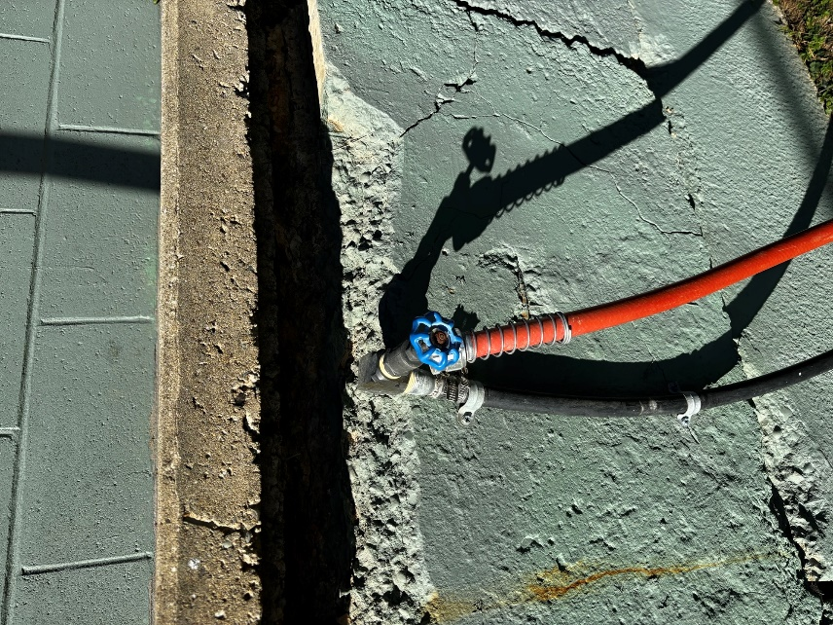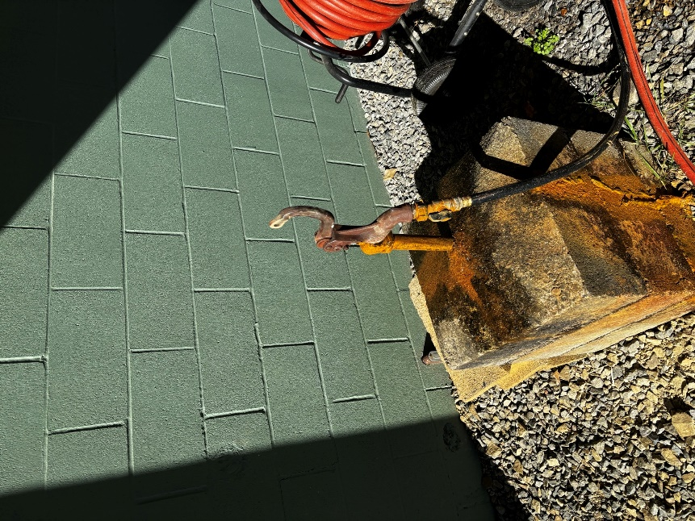
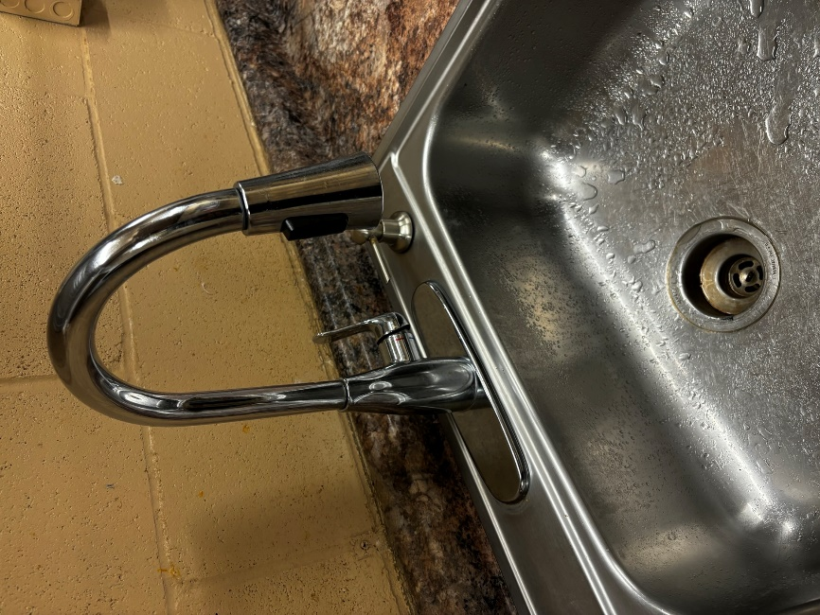

Step 3: Lift off the cover of the well head. Place a ladder from the garage into the well. Be sure that the ladder is not on the fittings/tank and is stable before you climb down.

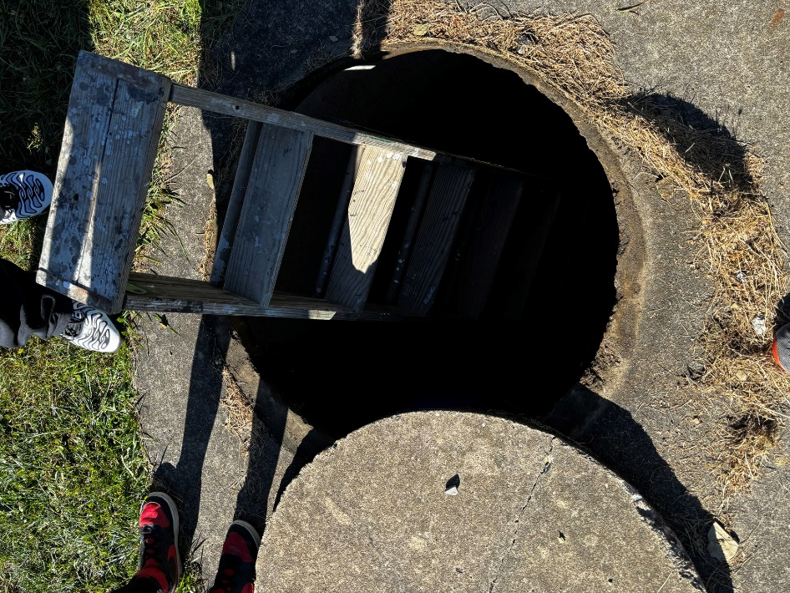

Step 4: Turn off the main shut off valve to the well head. Then open the hose fitting below (slowly) to drain all of the water out of the water tank. You can leave the drain valve open (but be sure to close in the spring).

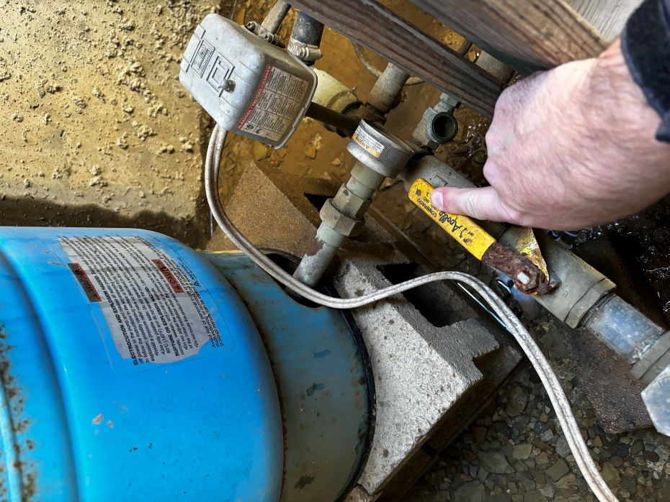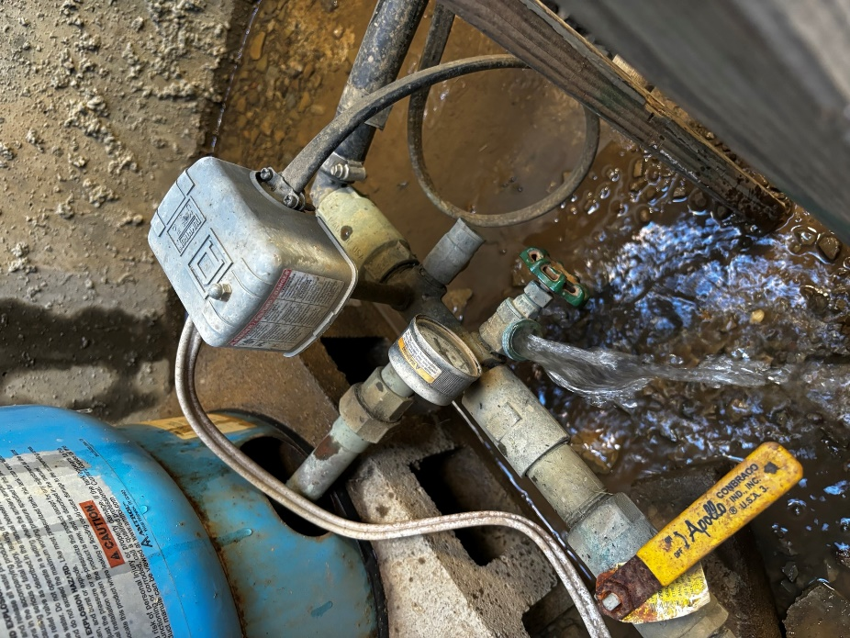
Step 5: Go to the concession stand. Go to the breaker panel in the back, left hand corner. Find the breakers marked “Hot Water” (7 and 11) and turn it off. This shuts off electric to the hot water heater.

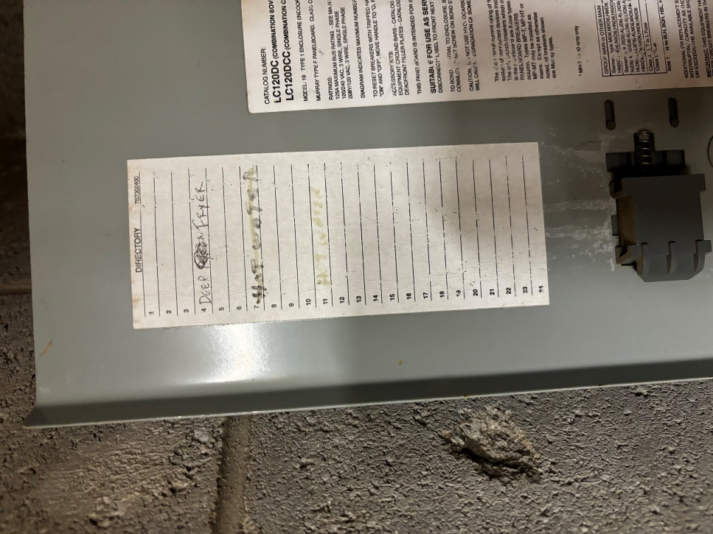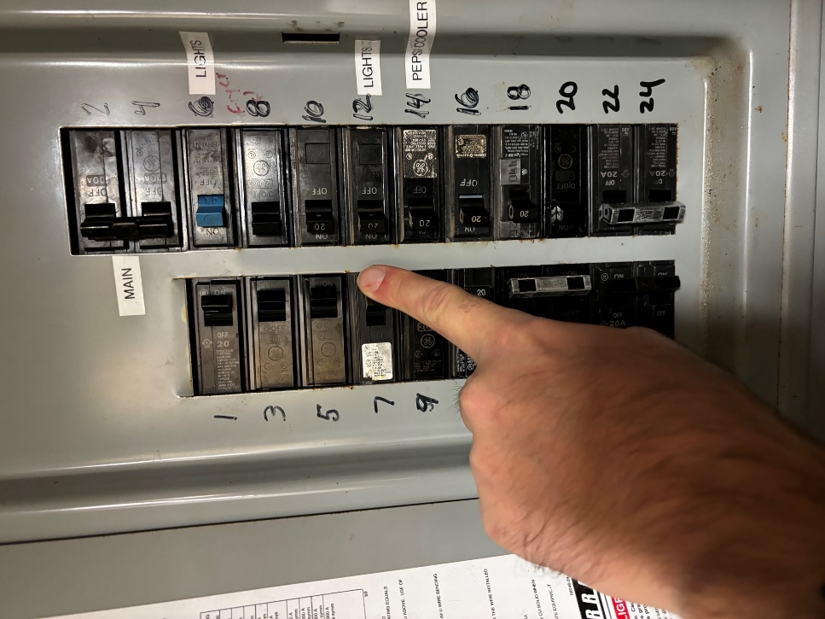

Step 6: Open the drain valve to the hot water heater. You can leave the valve open (but be sure to close in the spring).
