CT Baseball - Coaches Practice Playbook – Practice 10
Coaches Reminder – In addition to this practice plan, refer to the CT Baseball drill library to help customize based on the skill level of your team and desired focus areas.
Pre-Practice Huddle (5 minutes):
- Rule review – Batter swings and hits the catchers mitt. This is normally catchers interference. The play can continue if it’s put in play and the manager can choose to accept the outcome of the play, but more likely the batter will miss the pitch. Normally, the batter is awarded first base. Remind catchers to stay back from the batter.
- Discuss what went well/not so well in recent games/practices
Warm Up/Partner Skill Building (20-25 minutes):
- Follow the CT Baseball – Suggested Warm Up Routine guidelines
Stations (30-40 minutes):
- Divide players equally into groups – suggest 3-4 stations total depending on the number of assistant coaches/parent helpers. You can also split the team into two groups and change the stations after two rotations (for a total of 4 stations).
- Station 1 – Hitting - Suggested Drill – Drop Ball Drill (Medium): Batter gets in stance in front of the net. Coach stands on the opposite side holding the ball. Coach lifts the ball to signal the batter to trigger, then drops the ball.
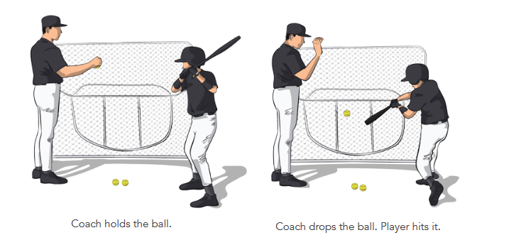
- Station 2 – Infield - Suggested Drill – 3, 2, 1 Run! (Medium): This drill is to teach players how to make quick, accurate throws under pressure. Set up the drill with two groups, a baserunning group at home plate and a fielding group at third base. 3 balls should be placed evenly between third base and home. The 3rd ball should be about half way to home. On the coach’s signal, the player on third will sprint to the first ball, pick it up, and throw to second base. At the same time, the runner from home will sprint towards first base. The fielding player has to pick up and throw all three balls to second base before the runner makes it from home to second. After the thrower completes their 3 throws, they rotate to second base. The second basemen rotates to the back of the line. After every fielder has gone, rotate the fielders with the baserunners. You can add a 4th ball to make this drill harder, or subtract balls or decrease the distance of the throws to make the drill easier. You can also run this as a timed drill instead of a race.
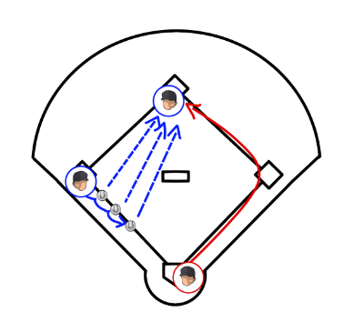

- Station 3 – Outfield - Suggested Drill – Break Down (Easy): This drill is to practice proper fielding technique for ground balls in the outfield. Fielder should stand in the outfield facing the coach. The coach will stand about 40 feet away and hit balls to the first fielder in line. The fielder should approach the ball, then drop their throwing side knee to the ground and put their glove between their legs to field the ball. The player should then rise, crow hop and throw back to the coach. Once this is mastered, you can have your players scoop the baseball when you’re attempting to aggressively throw out a runner (field next to your glove side foot, crouched and ready to hop).
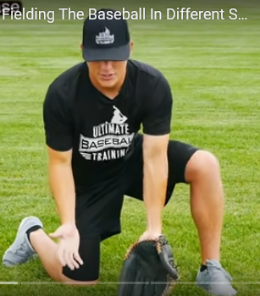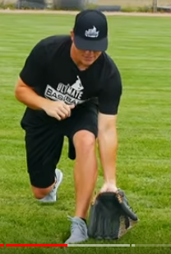
Station 4 - (Optional) Throwing - Suggested Drill – Knockdown (Easy – Medium): Place a tee with a ball on it about 20 feet from a line of players. Leave a bucket or pile of balls by the line. Have the players attempt to knock the ball off the tee. For younger players, substitute a large ball like a basketball, beach ball or soccer ball. You can also use a bucket flipped upside down with a stuffed animal on it for a target. For older players, have them pitch from the wind up or stretch.
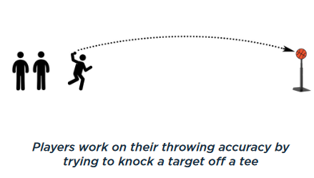
- Players will spend about 10 minutes at each station before rotating to the next
Water Break + Huddle (5-10 Minutes):
- Word of the Week – Focus
  - “Lock in! Watch, listen, think…. Right here, right now.”
  - Instead of just listening, hear, understand and clarify if needed. Try to understand the why and how behind everything we do at practice.
  - In order to be successful, you need to have the ability to focus on a task very closely – it’s hard to hit or catch a tiny baseball flying at you very quickly!
  - Team Building Activity of the Week – “Show us your focus! We’re going to play the game I spy!” Each coach gets a turn to pick the object, and kids try to guess it.
- Team Activity (25-30 Minutes):
Suggested Drill - Goal! (Medium): Using cones or a pop up net, set up a small soccer field with goals on each end. Place cones in the middle for a midline. Divide your players into two even teams, one on each side of the field. Give each team 2-3 tennis balls or other soft balls. The object of the game is to throw the ball into the other team’s goal. The ball must bounce before it goes into the goal. Each team will use their gloves to stop the ball. The first team to five goals wins. If you’re not using a net, goals only count if they are waist high or lower. Encourage good ground ball fielding fundamentals to stop the ball.

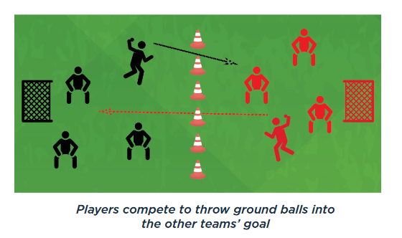
Fun Activity – Last Man Standing – Finish with a game of “last man standing” where players form a circle. One player has a baseball. The ball is passed around (like hot potato). A player is out if he drops the ball. Increase the difficulty level by adding a second baseball or having them catch with their right hand or left hand only.
Post Game (2 minutes):
- Remind players of next upcoming practice and any details regarding schedule
- Encourage teammates to practice at home with parents, guardians or friends

