CT Baseball - Drill Library
Hitting Drills:
Note that tee work is a foundational skill for all athletes from tee ball to the major leagues. The majority of drills that are done in small stations will be tee and soft toss work. These repetitions are important to establishing hitting mechanics at a young age that are easy to build on as the athlete progresses. Tee work should typically be done with the ball on the outside of the plate, aligned with the front foot of the hitter to discourage casting/bat drag.
Balance Beam Drill (Easy): Lay a 2x6 piece of lumber on the ground and have the player swing off the tee or soft toss. The player’s heels may hang off the edge a bit. Have the player do whatever they can to stay on the beam after finishing the swing.
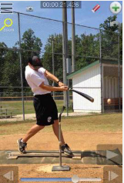
Double tee (Easy): Set up 2 tees, one on the front of the plate and one on the point (back) of the plate. Set a ball on the tee on the front of the plate. Try to hit the ball off the front tee with out hitting the tee that is in the back. This should keep your bat level through the zone and create backspin.
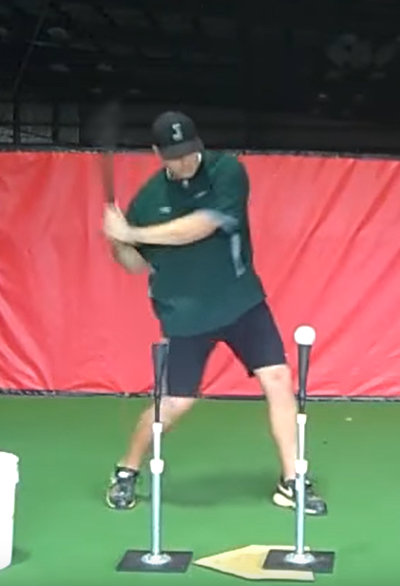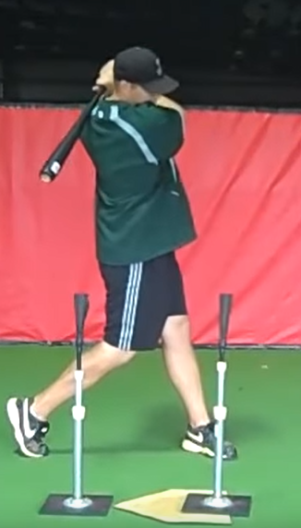
Overload/Underload Training (Easy): Swing with a heavier than normal (wooden, Camwood bat, or heavier youth baseball bat) for 10 swings, then swing a very light bat (tee ball, whiffle, or thin bat) for 10 swings. This builds strength, bat speed and adaptability.
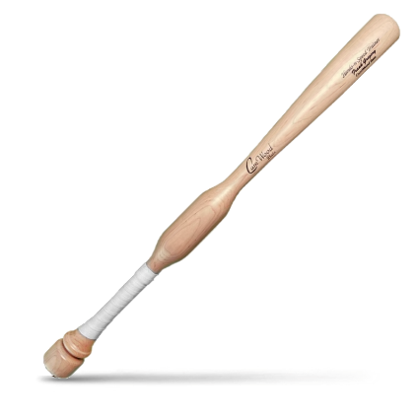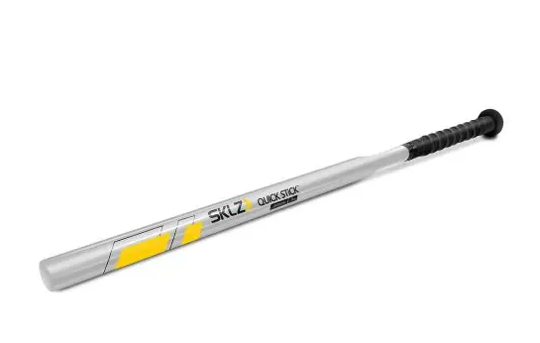

Knee kick drill (Easy): Set up a tee at the middle contact position. You will take your normal swing but just after contact, you need to push off your back leg and drive your knee high into the air. Two keys to remember are; drive your knee JUST AFTER contact and HOLD a balanced position with your knee high to avoid spinning out. It is important to drive your knee to the pitcher and not to swing your knee around your body.
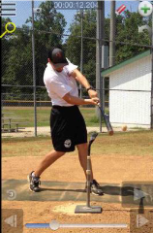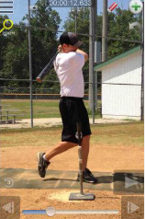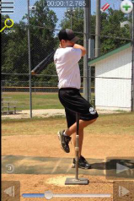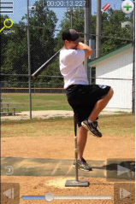

Overhand Firm Toss (Easy): Set up 15-20 feet from the hitter, throw the ball like a dart from a kneeling or sitting position. Use a squishy ball or a whiffle ball if you don’t have a screen. As the hitter makes better contact, increase the velocity of the pitched ball.
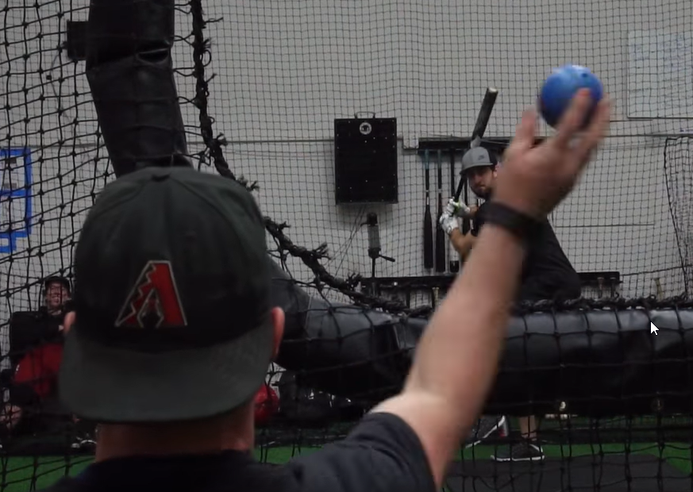
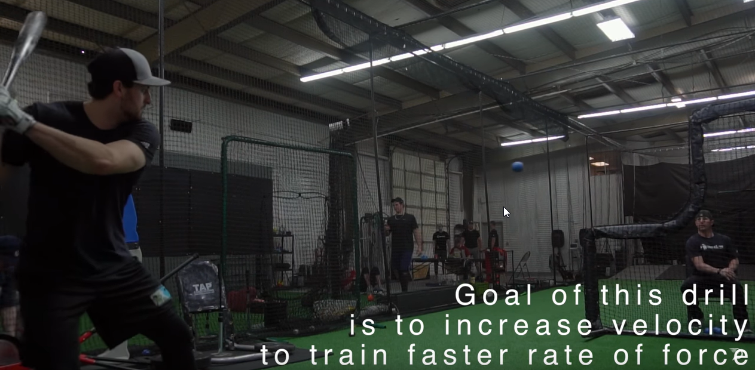

Coach Knockout (Easy): This is a fun drill for younger teams. Coach puts on full protective catcher gear and sits on a chair 15 feet from home plate. The hitter sets up and swings from his normal batting stance. The batter will try to knock the coach off of the chair. This can also be done with whiffle balls if you don’t want to gear up. 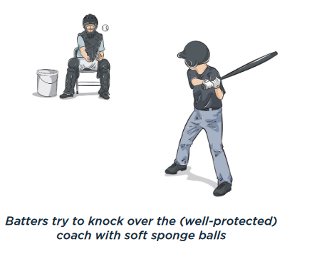
Step Drill (Easy): Batter stands in normal batting stance. Place a towel, bucket, bat or other item behind the front foot of the player. This will prevent the player from stepping out when swinging.
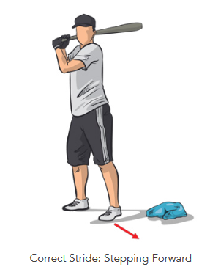
Pinball (Easy): Setup 3 buckets upside down on top of each other, with the tee about 20 feet away. Split the team into two groups to compete as teams, or have kids compete individually. Each player will attempt to knock over at least one of the buckets. The drill continues until one team (or player) has hit the target 5 times. You can make the bucket stack bigger (5 buckets) or smaller (1 bucket) to change the difficulty level.
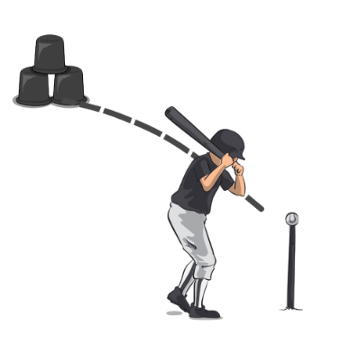
Swing-Hold-Drop (Medium): Swing using a tee, soft toss or even dry swings. Have the player hold their finish for a 3 count. Then the batter should drop their back knee to the ground slowly. Once the knee touches the ground, lift straight back up to your finish position. If they can’t hold their finish, they have poor balance and they may need to simplify their swing.
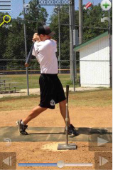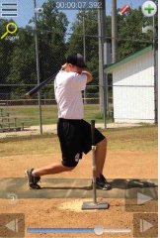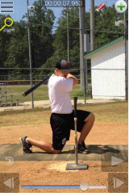

Hook Em’s (Medium): Have the hitter begin with their front foot over top of their back foot. They will load, coil on the back hip, then stride and complete their swing explosively. This drill is to focus on using the bottom half of the body to generate controlled rotational force on time.
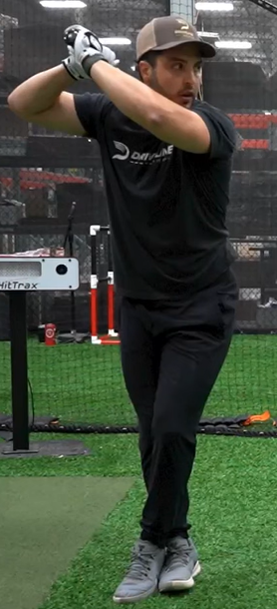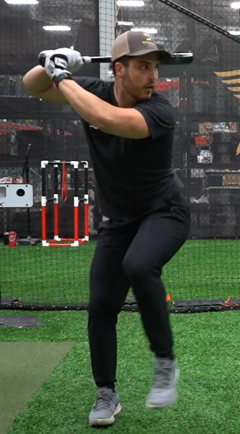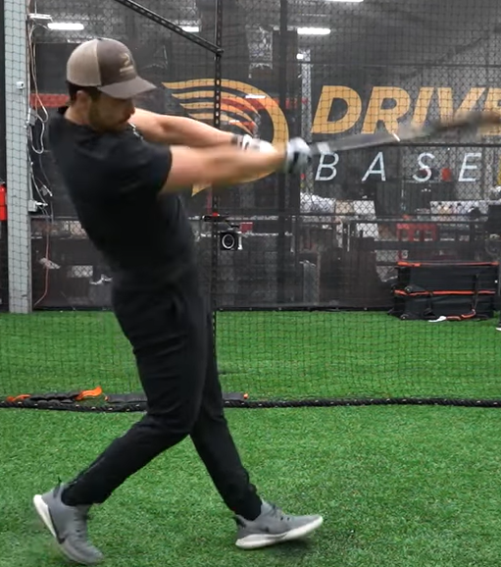

Step Back and Gather Drill (Medium): Using a tee, start with feet together and have the ball lined up with your belly button. Hands are relaxed, bat on shoulder. Now, step back with back foot, load hands back and swing. This will emphasize back leg load and keeping the hands back prior to triggering the swing.
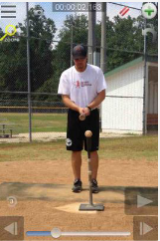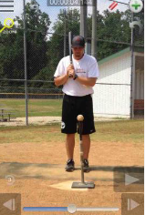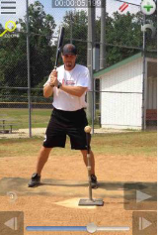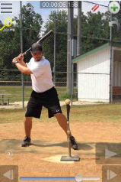

Off-Set Front Toss (Medium): Set up pretty far back from the hitter, diagonal and inside from their front hip. Use a tee ball, plyoball, or whiffle ball if you don’t have a screen. Objective – let the ball get deep in the strike zone and have the batter hit to the opposite field (stay closed).
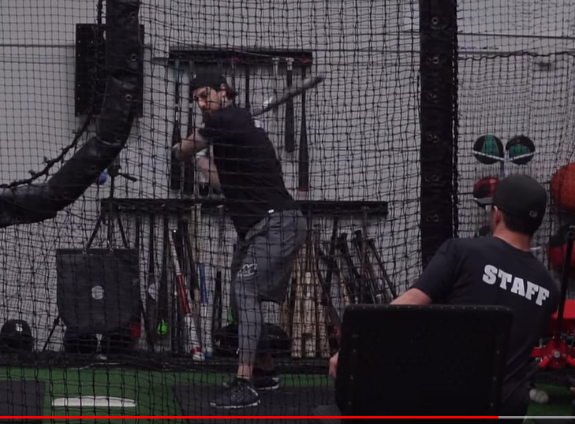

Offset Open/Closed (Medium): Have the hitter begin with their front foot very open or very closed. Do not stride, but rotate with good swing depth and direction, while coiling on the back hip and maintaining posture. Offset open will be better for players struggling with hitting the ball the opposite way, while offset closed will help with players struggling to the pull side.
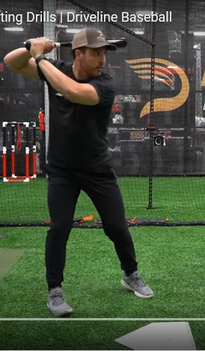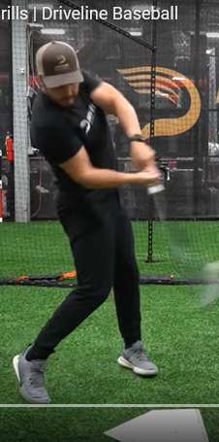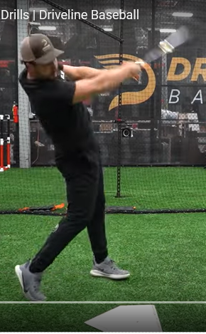
Drop Ball Drill (Medium): Batter gets in stance in front of the net. Coach stands on the opposite side holding the ball. Coach lifts the ball to signal the batter to trigger, then drops the ball.
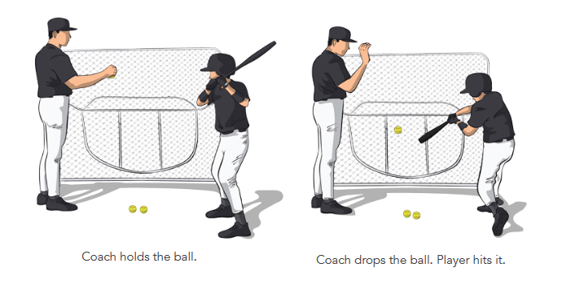
Pressure Hitting (Medium): This is a great drill to encourage making contact and driving the ball under pressure. Have the coach line up at the pitcher’s mound with a bucket of balls, one player in the batters box and the rest of the team in a line, ready to run. The coach pitches to the batter. The batter must swing no matter what. If the batter makes contact, the next batter steps up and the player that just hit returns to the sprinters line. If the batter misses, everyone must sprint to the outfield fence! If there’s a foul ball, the batter gets another chance. You can also use jumping jacks, sit ups or push ups. You can increase difficulty by only counting hits into the outfield (infield hits are foul balls). You can make it easier for young teams by giving 3 strikes.
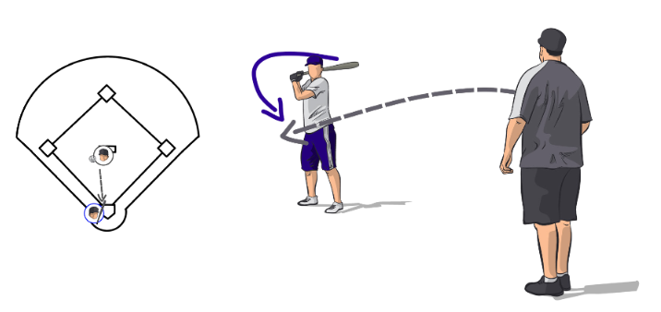
Knob to Knee Drill (Hard): This drill emphasizes getting the front (stride) foot down before triggering the hips and hands. Notice that the left knee rises across to the right shoulder, creating torque. Use a tee for this drill.
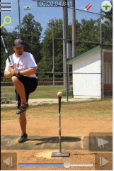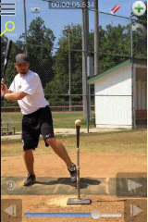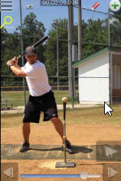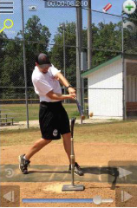

One knee hitting drill (Hard): Hit off a tee or soft toss. Kneel on the ground with your back knee down and front leg extended. This will take your lower body out of the swing. To create any type of bat-speed and not fall over, the player must use his hands correctly. Think of using an axe to chop a tree down. Be sure not to “roll your wrists” rather “un-hinge” them. ***Make sure the player uses a lighter bat or chokes up on his regular bat.
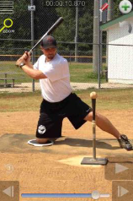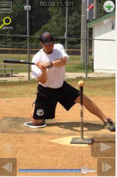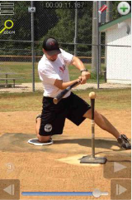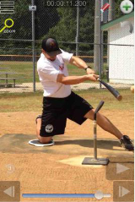

Walk Throughs/Happy Gilmore’s (Hard): Begin well behind the batters box. Take a small step forward with your front foot, then step behind the front foot with your back foot, then finally stride and “walk” into your normal swing. This drill is designed to bring rhythm and timing into unloading the swing.
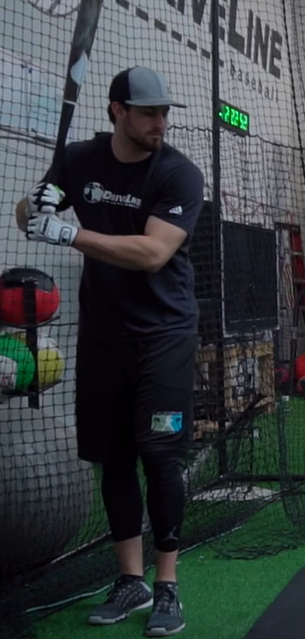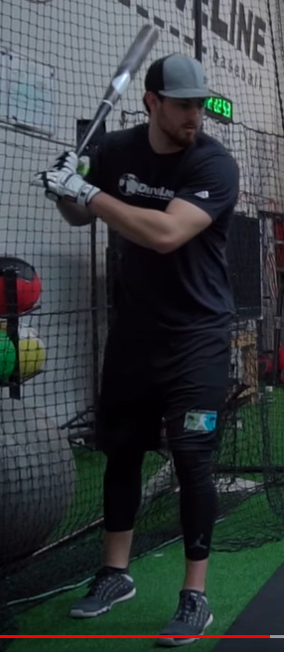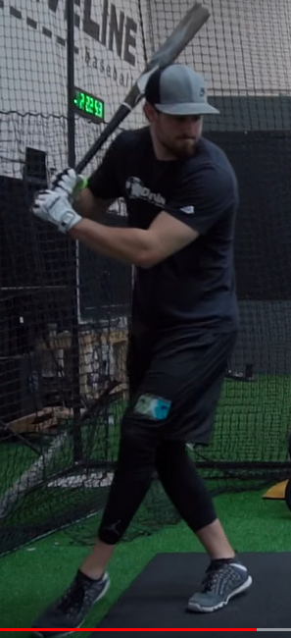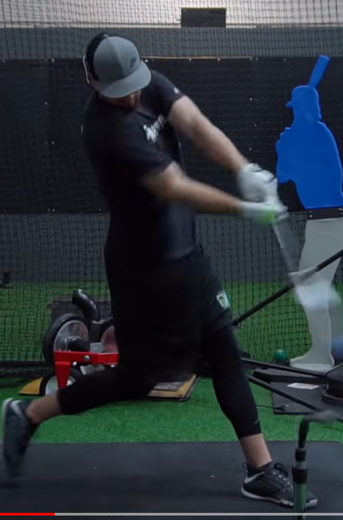

Back Toss (Hard): Tosser kneels 6-8 feet behind the hitter and tosses forward. This drill is similar to regular soft toss, but the tosser is directly behind. Players that “cast” the barrel will not be able to make contact with the ball.
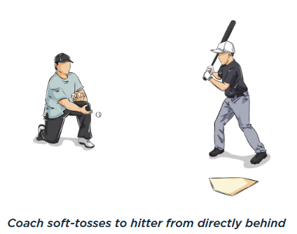
Two Ball Drill (Hard): Set up a normal soft toss, but have two balls in hand. The coach calls out “higher” or “lower.” The coach tosses both balls and the batter hits the appropriate ball.
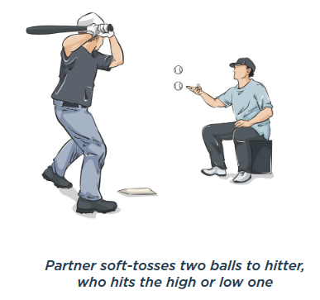

Running Drills:
Swing and Sprint (Easy): Line up your players at home plate in the batters box. Have each player simulate swinging, dropping the bat, then exploding to first base. Run all the way through first and into foul territory. You can time this to add a competitive element.
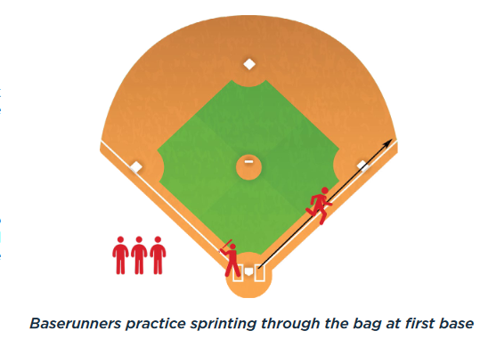
Baserunning Circuit (Easy): Have players practice making the turns around the bases. You can begin by having them turn just to second like a double. Then have them run all the way around the bases. You can time these with a stop watch to add a competitive element.
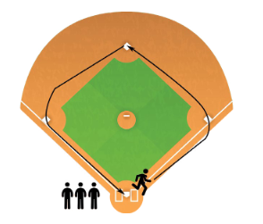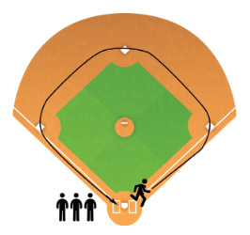

Progressive Tag Up (Medium): Put 3 or 4 fielders in the outfield, and players at first, second, short, third and catcher in the infield. Remaining players line up at first. Coach will hit or throw a ball in the air to an outfielder. Runners will practice taking a lead, assessing if the outfielder is going to catch it, and either returning to the base or running to second if the ball drops. Once the runner reaches second, you can practice tag ups with runners on first and second. The runner on second can tag up and go to third at their descretion. Set up again with bases loaded.
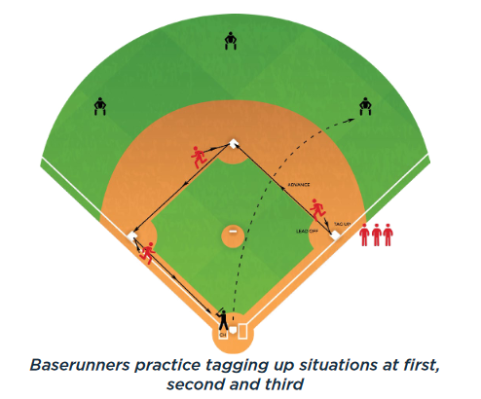
Slide Under the Tag (Medium): This can be set up on the infield, or in the outfield with two throw down bases. Players line up at first, coach stands about 15 feet away. Either another coach or a player stands at the second base, ready to take the throw. Allow the players to run from the first base, then time the toss to the second base so that the throw and runner arrive at almost the same time to get a tag down on the runner. Show runners the types of slides available to avoid the tag.
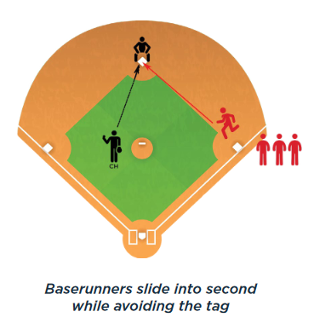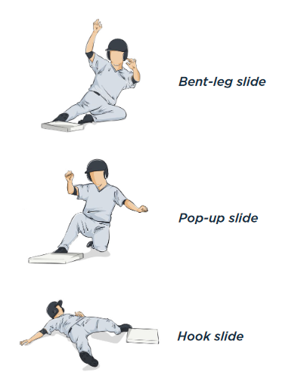
Race to Home (Medium): Split your players into three teams. One team lines up at home plate as baserunners, the second team lines up behind first base, the third team lines up behind third base. Coach kneels in soft toss position by home plate. The first player on the base running team steps up to the plate with a bat/helmet. Coach soft tosses, and player runs when the ball is put in play. The first player in the first and third base lines sprint to retrieve the ball as soon as it is hit. Once both fielders touch the ball, the runner stops. The baserunning team gets a point for each base touched. Keep track of the points and crown a champion.
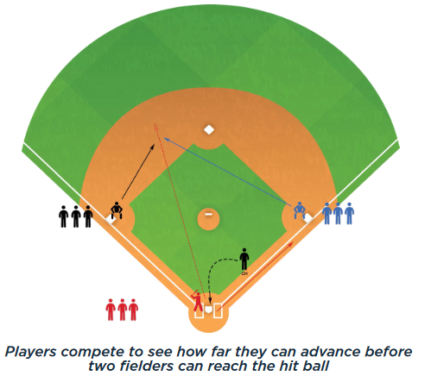
Around the Horn Baserunning (Medium): Split your players into two teams. One team lines up at home plate as baserunners, the second team plays the infield (outfielders optional as backups). Coach hits the ball to an infielder. The fielder throws to first base, then to second, then third, and finally home. At the same time the ball is hit, the runner leaves from home and attempts to make it all the way around the bases before the fielders get the ball back to home. The winner is whoever gets to home first.
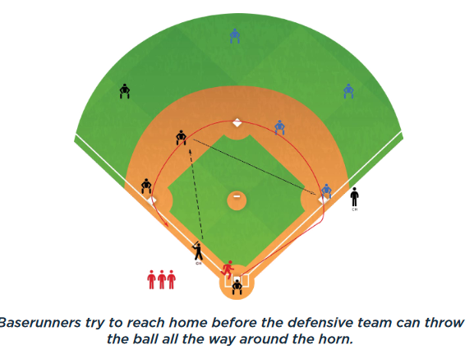
Rundown: Set up players on any two bases in the infield (or two throw bases in the outfield) with their gloves on. A third player is a base runner. The base runner is trying to get back and forth as many times as possible without getting tagged out. The runner begins by attempting to run to the next base. Fielders attempt to trap the runner by chasing and throwing the ball between them. For older age groups, you can also make this drill more realistic by adding a pitcher for pick offs and backups to cycle through (like a live game).
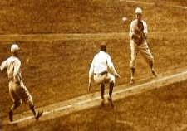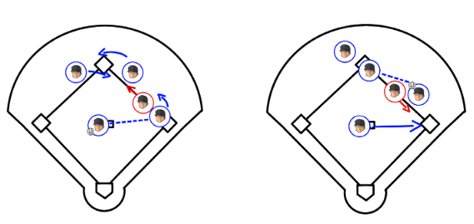

Infield Drills:
Catch-Pivot-Throw Relay (Easy): Line up players in a line with gloves. One player at the end has a ball. When the coach says “go” the player with the ball will throw to the next player in line. The player will step to the ball, pivot on his back foot, and complete the throw to the next player in line. Continue until the ball has made it to the end and then back to the first player. You can either time the drill, or play as teams to make it more competitive. If the kids haven’t seen the pivot footwork before, show them it in slow motion first.
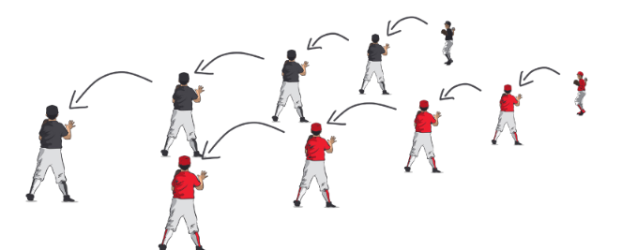
Knockdown (Easy – Medium): Place a tee with a ball on it about 20 feet from a line of players. Leave a bucket or pile of balls by the line. Have the players attempt to knock the ball off the tee. For younger players, substitute a large ball like a basketball, beach ball or soccer ball. You can also use a bucket flipped upside down with a stuffed animal on it for a target.
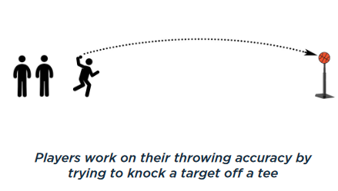

Grounder Goalie (Easy): Create a “goal” with two cones spaced about 10 feet apart. One player stands as a goalie between the cones with a glove on. Other players make a line. Either have a player back up the goalie or make the goal against a fence. The coach throws or hits grounders towards the goal with the goalie trying to keep the ball out of the goal. The goalie should make three stops (field 3 balls) before moving to the back of the line. This can also be played as a “knockout” game where a player is “out” if they let the ball behind them.
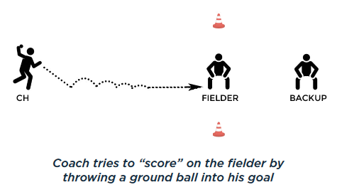

Short Hops (Easy): Divide players into pairs with the partners about 15 feet apart. Begin with players on their knees and gloves on. One partner is each pair has a glove. Partners throw the balls back and forth, with the throws short hopping to their partner on one bounce. To add a competitive element, you can have the players count when they miss a scoop. Players are eliminated when they get to 5 misses. As players advance, this drill can also be done standing up, to simulate a first basemen or infielder scooping a live ball.
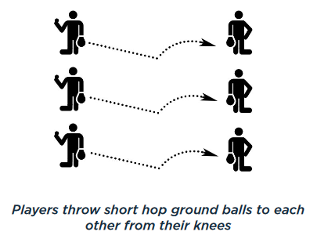

Underhand Flip Force Outs (Easy): This drill is to practice using the underhand flip to get force outs at second base. Make two lines of players, one at shortstop, one at second. Coach stands with a bucket of balls at the mound or home plate. Roll or hit a ball to the short stop. Second basemen should cover the base and reach with his right foot to the throw. Flips should be done in the bare hand, with the receiver clearly able to see the throwing hand. Flipper should step towards the target and follow through by pointing directly at the target (explain that they should be reaching out like they are “shaking hands” when they finish the flip. Flip should be relatively firm, but not fast. When complete, rotate to the next pair. You can alternate the drill by hitting to the second basemen with the shortstop covering. An advanced version of this drill would also have a player on first base and practice turning double plays.
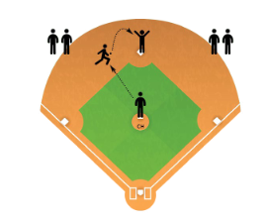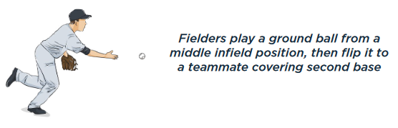

Infield Knockout (Easy): Players spread out in the infield (or form line(s)). A coach will stand at home plate with a bat and bucket of balls. Either a coach or a player will play first base (suggest a coach for younger teams). The coach will hit groundballs towards a player in the infield, the player must field the ball cleanly and throw to first base. If the player makes a mistake fielding or throwing, they are “out.” The coach continues until all but one player has been eliminated - that player is the survivor and winner. You can give 3 lives for younger players to get more opportunities. A variant of this knockout game is called “guts,” where the coach hits a soft ball very hard at the players, and they are only “out” if the ball gets behind them.
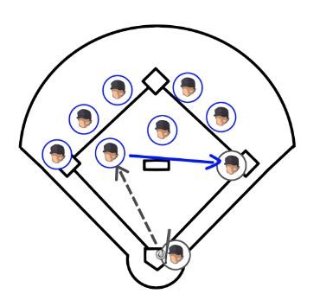
Foot replacement 4 Cone Drill (Easy): This drill is to teach proper transition from fielding to throwing, with the feet moving to turn the shoulder to the throwing target. Set up four cones in a square. The players will start in a line, and pretend to field a ball in the center of their body at the first two cones, then pivot and replace their feet to turn facing the next two lines in the square. They will repeat until they return to the first position in the square. The next player will then repeat the drill all the way around the square.
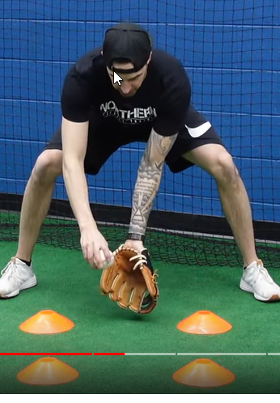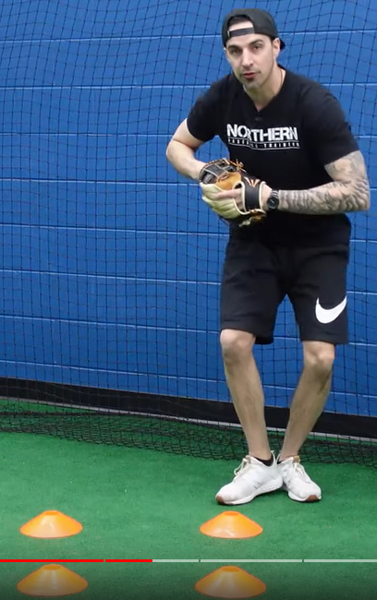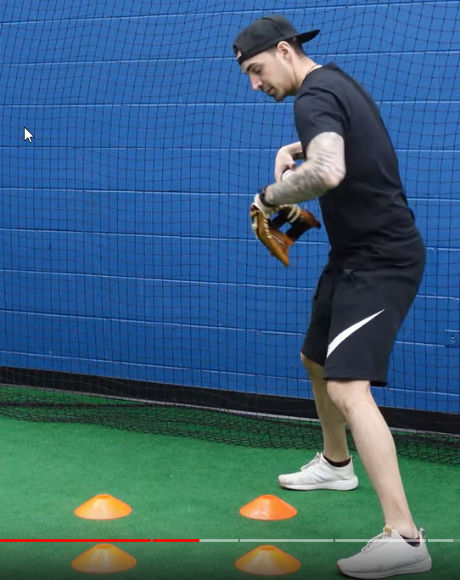
Infield Slides 5 Cone Drill (Easy): This drill is to teach players to move laterally back and forth and center the ball on their body when they can. Players will line up behind the first cone. The first player will shuffle back and forth through the 5 cones, pretending to field a ball after completing the shuffle steps across each cone.
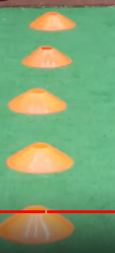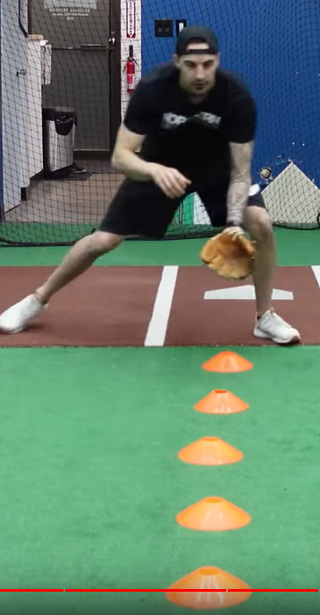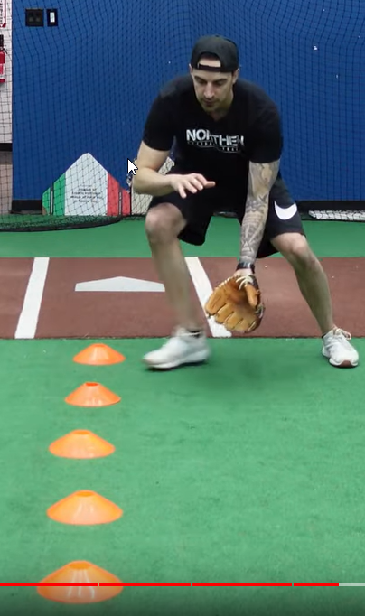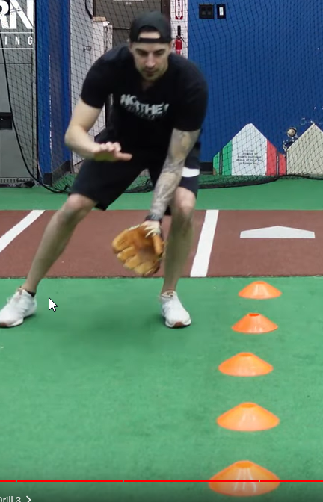

Ground Ball Faceoff (Easy): This is a high intensity game to get lots of fielding repetitions quickly. Divide team into two single file lines facing each other about 20 feet apart. All players have a glove. On the coach’s signal, the first player (with a ball) throws a grounder to the first player in the other line. After throwing, the player immediately runs to the end of the other line as fast as they can. The player in the receiving line fields the ball and throws a grounder for the next player in the other line. Play continues at a fast pace – field-throw-sprint. This game can be made more competitive by timing it to see how fast the players can get through the full team, or counting errors and awarding a win to the player with the fewest mistakes.
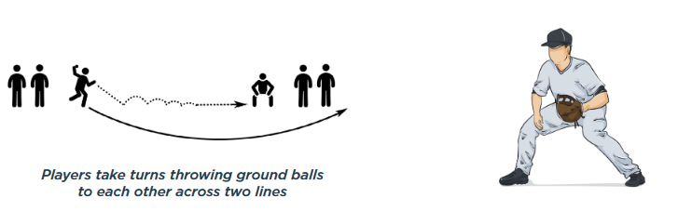
Infield Combo Drill (Easy): This is a good drill to generate a high number of key repetitions quickly. Start with the fielders in a line with gloves on and a ball in their glove, about 20 feet from the coach. The first player will throw the ball to the coach. The coach will throw a ground ball to the player. The player will field it and throw it back to the coach. The coach will then throw a short pop fly to the player. The player will catch it and make a strong throw back to the coach. Finally, the coach will bounce a slow roller to the player, who will field it (usually bare handed). The player will then take the ball and get in line behind the coach. Each player will rotate through until all players are behind the coach. The drill can start over again if desired by having the coach walk to reestablish the 20 foot distance to the player line and rotate through the order again.
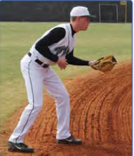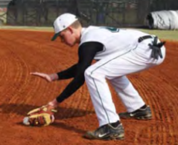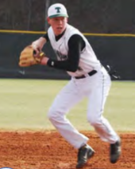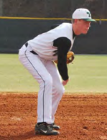

Around the Horn Throwing (Medium): Set up players on each base in the infield. You can also do this in the outfield with throw down bases. All players need a glove. The player at home has the ball. When the coach says “go”, the player at home will through to first, then first to second, second to third and finally third to home. The drill continues with the ball being throw around the horn. Make it competitive by seeing how many times they can get around the horn in 1 minute or the number of successful throws without a drop. You may need to move the players in to shorten the distance for younger players.
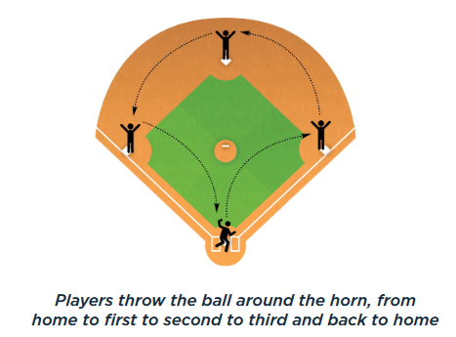
Barehand Throwing Gauntlet (Medium): This drill is used to practice executing a quick pivot in both directions after fielding a ball, and to ensure balls that are not moving are picked up with their bare hand. Line up 4 balls in a straight line, leaving 5 feet of space between each ball. Position “Catchers” about 15 feet from each ball (as shown). When the coach says “go” the runner will pick up each ball and throw to the appropriate catcher. As soon as the ball is caught, the catcher will put the ball back in place in the running line. After the first runner/thrower completes the gauntlet, the coach can send the next player. Rotate the runner/thrower and catchers after each completion. You can make this a competition by timing the drill, or completing as a race between two teams.
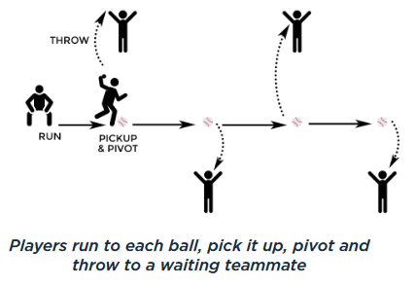
Goal! (Medium): Using cones or a pop up net, set up a small soccer field with goals on each end. Place cones in the middle for a midline. Divide your players into two even teams, one on each side of the field. Give each team 2-3 tennis balls or other soft balls. The object of the game is to throw the ball into the other team’s goal. The ball must bounce before it goes into the goal. Each team will use their gloves to stop the ball. The first team to five goals wins. If you’re not using a net, goals only count if they are waist high or lower. Encourage good ground ball fielding fundamentals to stop the ball.

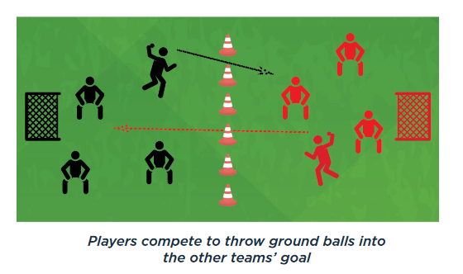
Center, Left, Right (Medium): The coach will line players up about 10-15 feet away in the infield. Players will receive 3 ground balls from the coach in quick succession. One ball will be in the center of their body, one slightly to their left, one slightly to their right. The objective is to teach the footwork for center, forehand, and back hand pickups. After fielding, the player will gather the ball like they’re ready to throw, but then flip the ball back to the coach softly. On the forehand, the player should drop their glove side foot to angle towards the baseball. On the backhand, the arm side foot should drop. The cross over backhand should only be used in emergency situations (i.e. diving).
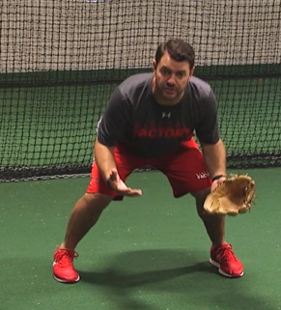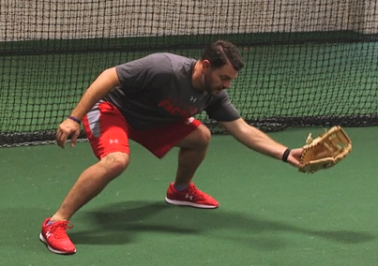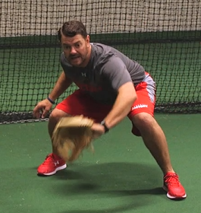
3, 2, 1 Run! (Medium): This drill is to teach players how to make quick, accurate throws under pressure. Set up the drill with two groups, a baserunning group at home plate and a fielding group at third base. 3 balls should be placed evenly between third base and home. The 3rd ball should be about half way to home. On the coach’s signal, the player on third will sprint to the first ball, pick it up, and throw to second base. At the same time, the runner from home will sprint towards first base. The fielding player has to pick up and throw all three balls to second base before the runner makes it from home to second. After the thrower completes their 3 throws, they rotate to second base. The second basemen rotates to the back of the line. After every fielder has gone, rotate the fielders with the baserunners. You can add a 4th ball to make this drill harder, or subtract balls or decrease the distance of the throws to make the drill easier. You can also run this as a timed drill instead of a race.
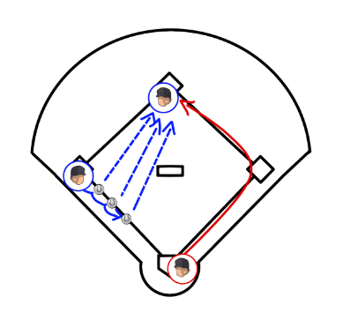

3 Cone Drill (Hard): The coach will line players up about 10-15 feet away in the infield. 3 cones will be set up directly in front of the first player in line. The player will start behind the closest cone in a fielding ready position. As the coach rolls the ball, the player will circle to the outside of the second cone, then field in front of the third cone. This drill teaches players to round the baseball with their body weight moving towards first base to make a strong throw. This drill is not hard, but is typically for more advanced players that have solid fielding and throwing fundamentals already established.
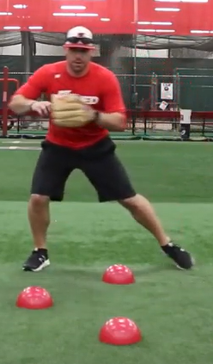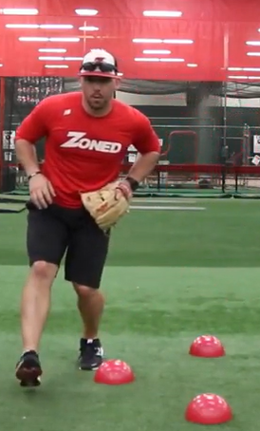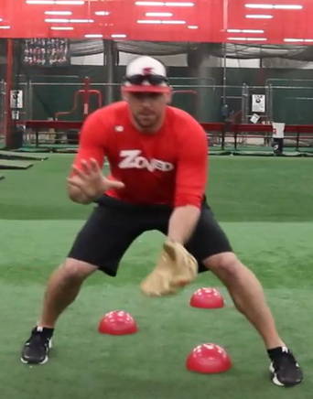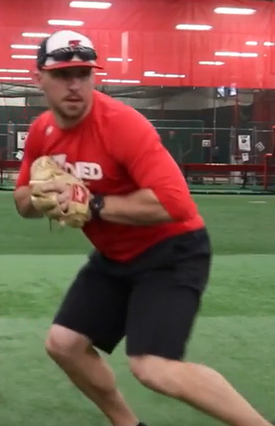

Outfield Drills:
Long Distance Throw (Easy): This drill is to help build arm strength. Players line up on an outfield line. On the coaches signal, players will throw as far as they can (no crow hops allowed). After the first round is complete, have the players run and retrieve their ball. Coach will show/instruct players on how to use a crow hop. Second round will be with a crow hop throw. Repeat for several rounds, with each player trying to set a personal record.
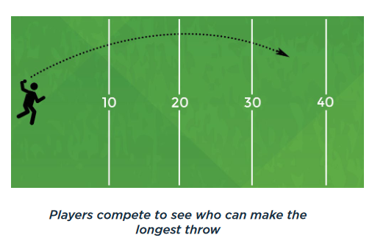
MINE (Easy): This drill is to practice common communication between fielders. Coach stands 5 feet behind second base with a bucket of balls. Place outfielders in two lines in right center and left center. All players should have a glove. Coach throws a high pop fly between the outfielders. The player closest to the ball should shout “Mine Mine Mine!” The other player should move to back up. Both players go to the back of the line and the drill begins again with the next player.
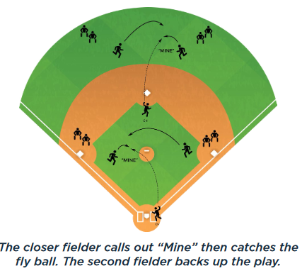

Break Down (Easy): This drill is practice proper fielding technique for ground balls in the outfield. Fielder should stand in the outfield facing the coach. The coach will stand about 40 feet away and hit balls to the first fielder in line. The fielder should approach the ball, then drop their throwing side knee to the ground and put their glove between their legs to field the ball. The player should then rise, crow hop and throw back to the coach. Once this is mastered, you can have your players scoop the baseball when you’re attempting to aggressively throw out a runner (field next to your glove side foot, crouched and ready to hop).
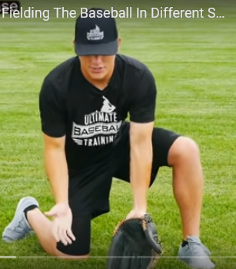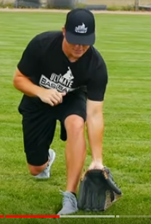
Wide Receiver (Easy): The coach lines up as a quarterback with a bucket of balls and a line of players 10-20 feet to their left. On the coach’s signal, the players sprint downfield and then turn in on a 45 degree angle to make a “post” pattern. Just after the turn, the coach will throw a fly ball to the player. After the player complete their attempt, they line up on the other side of the coach. Once all players are done on the left side, the coach will throw post patterns with the players coming from the right side. The drill is complete when all players have gone on both sides. You can make this drill easier or harder by having the patterns closer or further away.
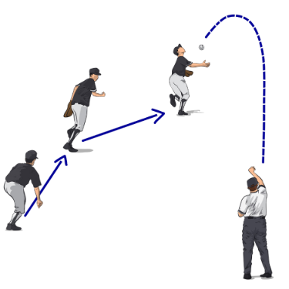

Trash Can Relay (Medium): Divide players into two teams. Position one player in left center, another at shortstop. The second team will have players in right center and second base positions. The coach will start by hitting or throwing a ball into the outfield for the left field team. The outfielder will relay to the shortstop, then throw home to a trash can (or other available) target. The team gets a point if the relay throw hits the target. The infielder will rotate to the back of the line, and the outfielder will rotate to the infield position. Immediately after the left field team is done, begin the drill again with the coach hitting to the right field team. End the game after a set number of target hits or a set time. Emphasize with this drill that dead balls against the fence need to be picked up in the bare hand, and the player needs to turn to their glove side to get the ball in fast.
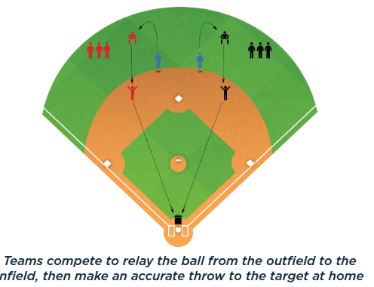
Drop Step Drill (Medium): This drill is to practice moving backwards on pop flies and line drives. Create a line of fielders (with gloves) standing 20 feet from the coach. The first fielder should be in ready position, looking at the coach. The coach throws the ball, and the fielder uses a drop step to move back to catch the ball. The fielder should catch and smoothly transition to throwing the ball back to the coach. The drill begins again with the next player. Be sure to demonstrate the drop step footwork for younger players before beginning. To start, you can concentrate on dropping to only one side at a time to make it easier for young players to repeat correctly.
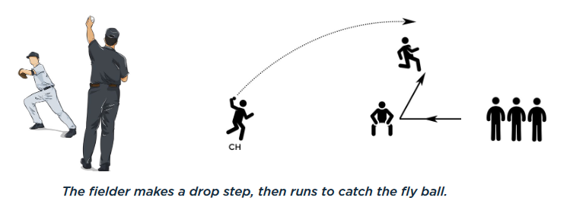

Doubles (Medium): This drill reinforces the importance of getting the ball back into play quickly on a drive into the outfield. Have 3 or 4 outfielders, a 2nd baseman and a shortstop on defense. Split the team into two groups – fielders and batters. A batter steps up and the coach soft tosses the pitch to the batter (or a tee or normal pitching can be used). The ball is live when the batter hits the ball into the outfield. No matter what, the batter has to attempt to get to second base. The outfielders will relay the ball to second base and try to get the runner out. A coach can hit if players aren’t strong/old enough to consistently hit the ball to the outfield. Emphasize picking up non-rolling balls in the bare hand and turning to the glove side.
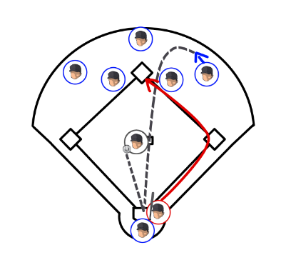
Dive Drill (Hard): In the outfield grass, have a fielder kneel about 15 feet away from the coach. Fielder has a glove, coach has a bucket of balls. Coach begins by flipping the ball just outside of the reach of the fielder. Fielder must drive from a kneel to catch the ball. Once the players master this, have them stand up and dive. The coach can get progressively further away as the players gain competence.
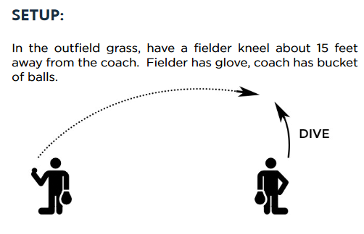

Fence Fly (Hard): Players form a line about 10 feet from a fence with gloves on. Coach has a bucket of balls and stands 20-30 feet from the line. Coach throws high arching balls designed to land between the fence and the player. The player needs to find the fence, then catch the ball. When the ball is caught, the fielder throws the ball back to the coach and the next player in line steps up.
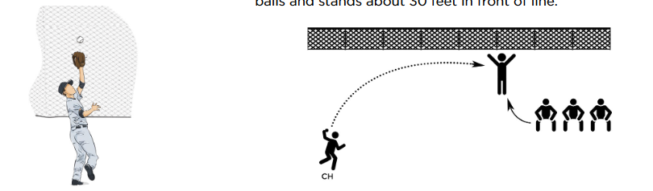

Hip Flips: Set up 5 cones zig zagging back and forth. Start with the kids practicing going to the next cone back, flipping their hips and then zagging to the next cone back. Second time through, throw at the last cone. Third time through, throw randomly between flips.
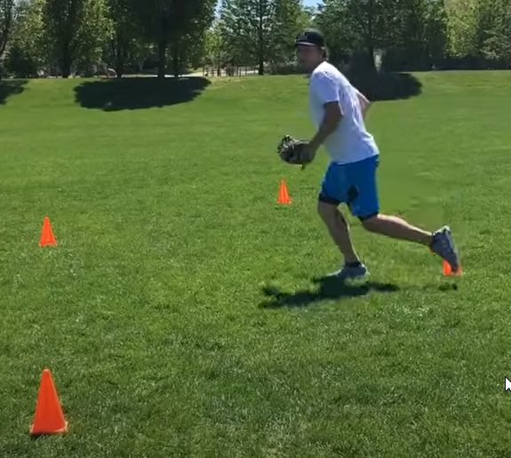
Pitching Drills:
Note – it’s especially important for pitchers to warm up well before pitching to decrease the risk of injury. I strongly recommend utilizing the CT Baseball Suggested Warm Up routine to teach fundamental throwing techniques and prepare the body to throw. Pitchers should also be more disciplined in completing static stretching exercises after games or practices when they have pitched. Pitching arm injuries are by far the most common major injury for baseball players.
21 (Easy): This is a competitive game to force players to improve their throwing accuracy under pressure. Have players pair off and stand at a comfortable throwing distance (older players move further away). The player without the ball will extend their glove towards their teammate, palm out, making a target. The thrower must hit the glove so accurately that the catching player doesn’t have to move their glove. If the player moves less than 2-3 inches the thrower gets two points. If the throw is above the waist and inside the catchers body/frame, it’s 1 point. The first partner to 21 wins.
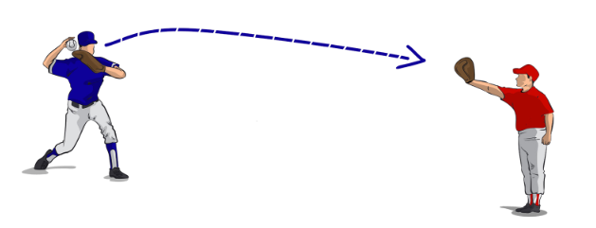
Waltz (Easy): This drill is good for timing, coordination and balance. Players can stand anywhere on the field. No baseball is required. Have the players gather on their normal pivot foot, with hands in the center of their body, then hop to their stride foot. Balance on the stride foot and hop back to the pivot foot. Repeat this 15-20 times.
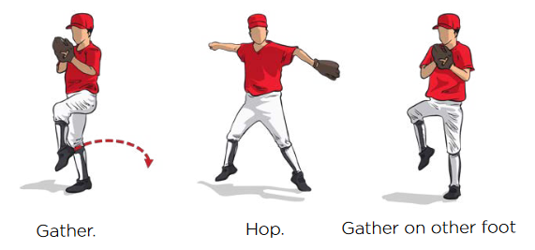

Balance, Power, Finish (Easy): The purpose of this drill is to establish balance at three crucial stages of the delivery. This drill is typically done with partners, gloves on, and a baseball for each set of partners. Have the pitchers begin by lifting their stride leg and balancing with their leg up for several seconds. Coaches can even gently push the players leg and see if they can maintain their balance. Next, have the player separate their hands and stride, with throwing arm back and glove hand tucked, pointed towards the target in the power position. Have the player pause in the power position and check for balance and arm/leg position. Finally, have the player finish their delivery in a follow through, with balance on their stride foot and prepared to field the baseball. Note that pitchers that throw with good velocity tend to “fly open” and spin off towards first base (right hander) or third base (left hander). This is acceptable and necessary to generate velocity, but for many youth pitchers it’s important to teach balance to improve thrown accuracy and provides the pitcher with the ability to protect themselves when a ball is hit to them.
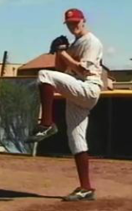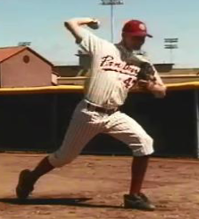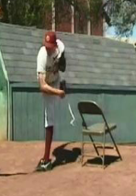
Upward Tosses (Easy): Holding the ball in your throwing hand with arm out to the side and forward, throw the ball up and catch it as it begins to fall. This is a natural arm slot and this drill trains the arm to find that natural L position. This will also build strength in the arm.
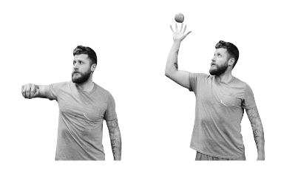

Pivot Foot Hop (Easy): Line pitchers up with partners, gloves on, and a baseball for each set of partners. The drill begins with the player taking their rocker step, pivoting and getting their foot parallel to the rubber. The pitcher will bring their stride leg up in a controlled motion, then he will hop three times on his pivot foot only. After three hops, he can stride and deliver the baseball to his partner. The idea is establish a good balance point on the pivot foot, and team the pitchers to coil and launch off of the pivot foot to accelerate the hips and lower body with the throw.
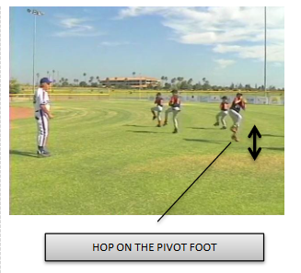
High Five (Easy): This drill focuses on a powerful follow through. The pitcher will get into the power position with stride foot down and arms in the “T” position. The coach will kneel down and high five the player. The pitcher will then simulate completing his follow through against the resistance provided by the coach. No baseball is required for this drill.
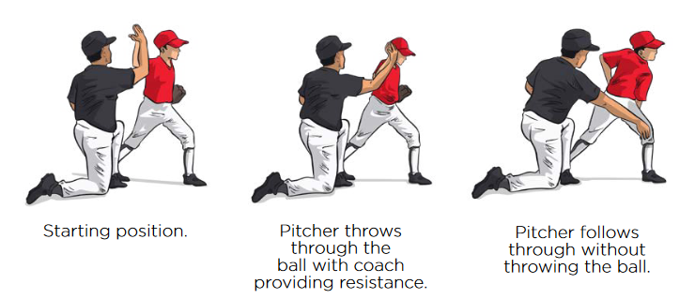

Front Screen/Fence Drill (Easy): The purpose of this drill is to eliminate excessive movement in the throwing arm and legs, and encourage striding directly toward the plate. With the pitcher on the rubber, set the screen (or fence) roughly 6-12 inches from the pitchers toes. The focus is for the pitcher not to contact the fence when working through their stretch or windup.
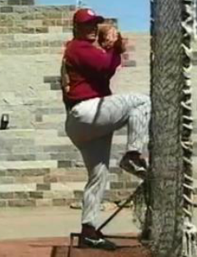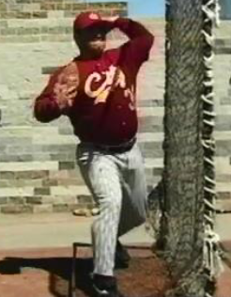
Back Screen/Fence Drill (Easy): The purpose of this drill is to eliminate excessive movement in the throwing arm and legs, and encourage striding directly toward the plate. This drill is good for pitchers that open up too far, hook their arm or have erratic arm action/slot. With the pitcher on the rubber, set the screen (or fence) roughly 6-12 inches from the pitchers heels. The focus is for the pitcher not to contact the fence when working through their wind up or stretch.
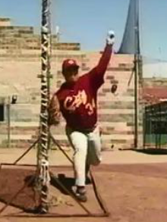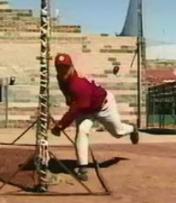

Uphill Drill (Medium): This drill creates good arm extension and a “downhill” plane from the pitcher. Have the pitcher start their windup/stretch from behind the mound, with their lead foot planting uphill onto the back of the pitchers mound. Be sure to move the catcher forward a few feet to correct for the longer distance. If the pitcher doesn’t have a firm stride and plant, they will spin off and recoil to the side.
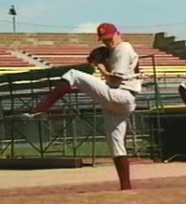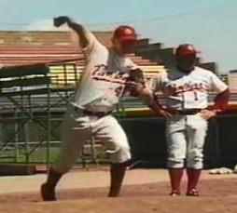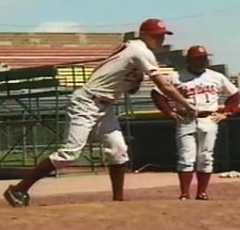
Hook ‘Em Pitching (Medium): This drill encourages loading the rear hip and coiling in order to drive the hips through, as well as developing earlier hand separation. This drill is typically run with partners with gloves on and one ball per set of partners. Pitcher should concentrate on establishing back hip coil when rising into the balance position with stride foot raised.
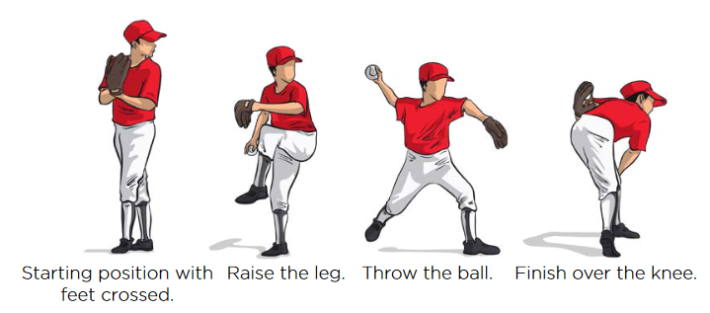

Roll in Throws (Medium): This drill is used to emphasize the timing of rotation and a braced stride leg on impact. Stand facing the target with ball in throwing hand at waist level. Take a walking step with throwing arm leg and drive powerfully into foot strip. Drive throwing arm directly back with no arm swing, fold glove arm and deliver ball. This drill can be done with a partner, or against a fence.
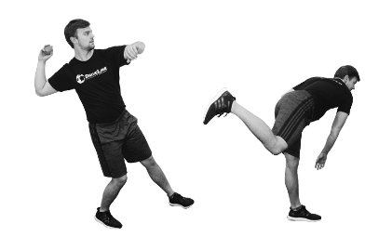
Rocker Throws (Medium): This drill emphasizes front side brace and long, powerful stride length. Start the drill with feet at full stride length and front foot slightly close from target. Rock back and forth and then throw the ball to the target, finish by bringing back leg through and following through. Rotate around a braced (not flexed) front leg. This drill can be done with a partner, or against a fence.
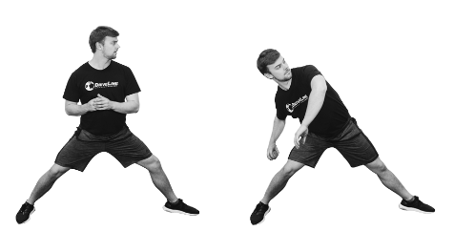
Towel Drill (Medium): The pitcher and a partner stand three strides apart. Pitcher sets and works through their delivery, with a towel in their hand instead of a baseball. On the follow through, the pitcher will attempt to extend the towel so it hits their partners mitt directly in the center. If they miss left/right, it’s a posture issue, if it’s short, they need to stride longer and with more acceleration. Lighter towels work better for this drill.
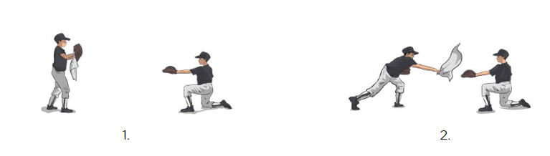
Reverse Throws (Hard): This drill trains the shoulder to be able to accept more velocity and builds flexibility in the spine. Pitcher kneels onto stride side knee with throwing arm pointed down and baseball in hand. Pitcher drives the throwing arm back at head height. This drill is best done against a wall or fence.
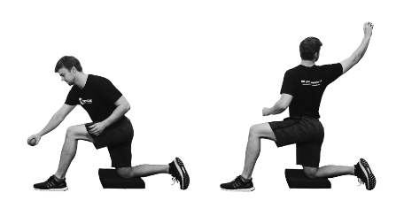
Torso Rotation Throws (Hard): This drill improves rotation in the delivery. Begin with feet and torso pointing perpendicular to the target. Place hands in the “T” power position with ball in throwing hand and glove side arm beginning to tuck. Rotate and throw the baseball, tucking the glove side in. The feet will naturally rotate to face the target. This drill is best done with a partner, or against a fence.
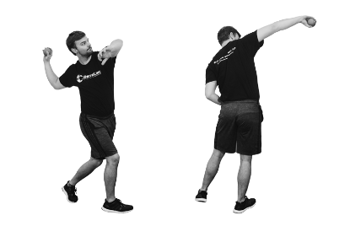
Pitch Grips:
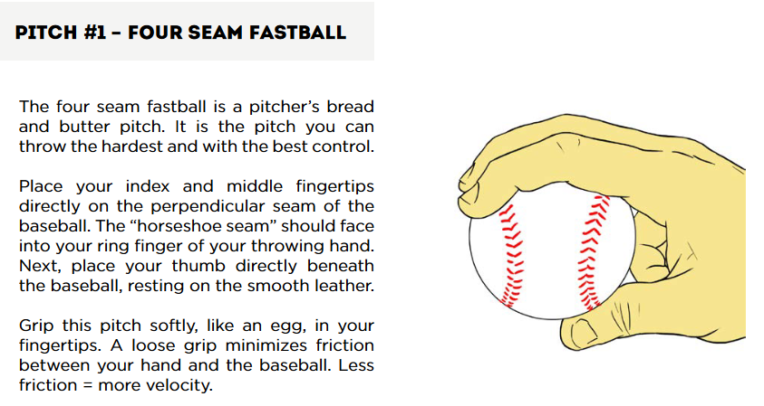
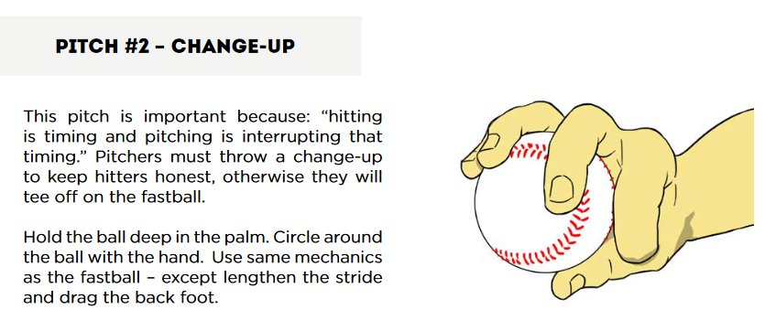
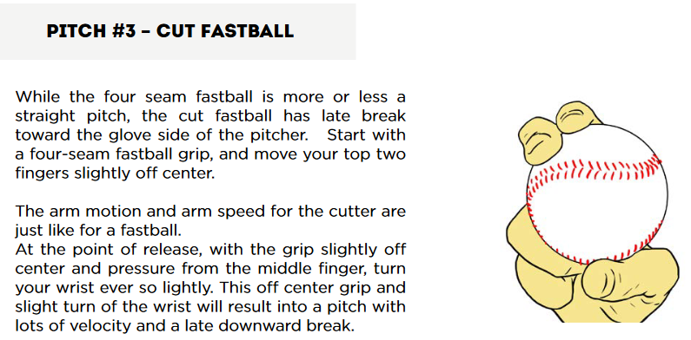
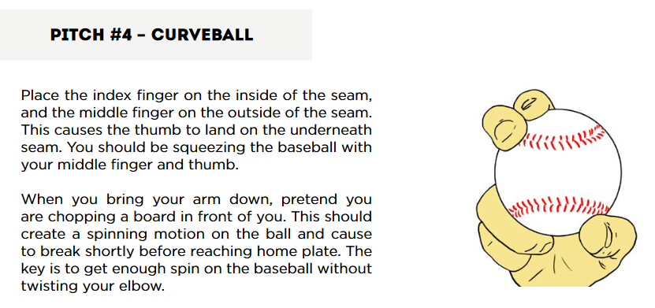
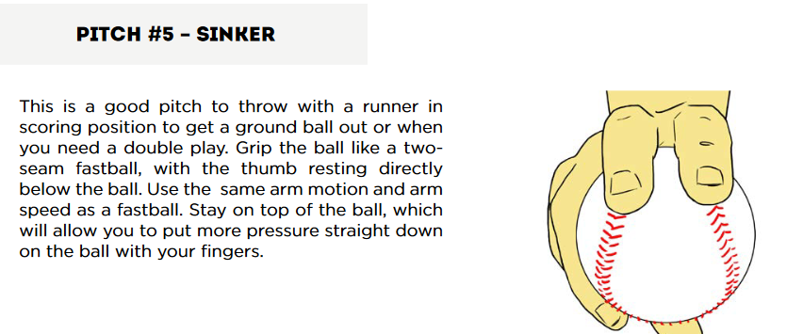

Catching Drills:
Stance (Easy): Have a group of players face the coach with around 5 feet of space between them. You can practice with just a glove. Help the players get in the proper catchers stance – athletic stance with feet slightly wider than shoulder width apart, drop elbows to your knees, point the toes slightly outside, keep knees inside feet, drop lower into the stance into you reach a comfortable position. Throwing hand behind the back or immediately behind the glove. Practice stance for no-runners on (sit on the legs) and runners on (widen legs, come slightly out of your stance, hand behind the glove and ready to throw). Repeat getting into the stance 4-5 times each (runner on, no runners on).
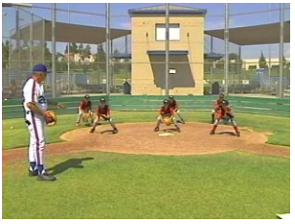
Step to the ball (Easy): With catchers down in their stance and glove up, have a coach point to the right or left. Catchers will immediately take a short, controlled step in the direction of the point, then move back to middle.
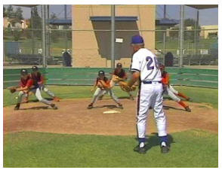

Catch and Grip (Easy): With catchers down in their stance (runners on), place a ball in each catchers glove. Have the players practice stepping to the ball, rising, stepping forward with the glove side foot, reaching into the glove to grip the ball, cocking the arm back to throw, and then freezing with throwing arm side foot extended and ready to ready.
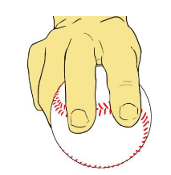

Dirt Balls (Medium): Set catchers in their stance with gloves on. From 5-10 feet away, toss the ball into the dirt in front of the catcher. The catcher should quickly lower himself onto his knees to block the ball. Try mixing it up by throwing dirt balls to the left, right and middle of the catcher. As the catcher gets the technique down, put on full equipment and begin throwing dirt balls from a longer range.
- Replace your feet with your knees in one, fluid motion
- Drive your knees into the ground where your feet were (about shoulder-width apart, with your upper body centered between them.
- So that you can get to your knees easier, clear away your feet by sliding them out to the side of your body.
- Keep your shins on the ground and your toes pointed back and away from you to be in the best position to block the ball.
- As you see the ball approaching the dirt, drop your mitt between your legs. The web of your mitt should be in contact with the ground, and the palm of your glove should be squared towards the pitch. Your fingers will be below the ball.
- Tuck your arms: As you drop your glove, keep your throwing hand poised above the mitt or tight to your throwing-side. Your glove-side arm should be tight to your body, making a larger blocking area.
- Your upper body should be straightened and angled forward, over the ball. By doing this, you can knock down the ball and deflect it straight into the ground, rather than away from you.
- Tuck your chin and always watch the ball.

Catcher Target Practice (Medium): Place a target (trash can, stuffed animal, bucket) on first, second or third base. Have a coach throw the ball to the catcher and simulate transferring to the throwing hand and throwing runners out at each base.
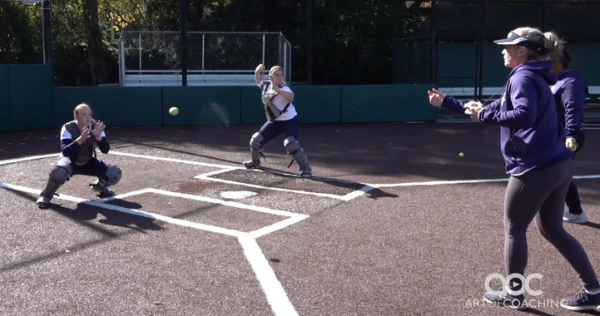
Catcher Volume Throwing (Medium): Place 12 baseballs about 12 inches apart, starting in front of home plate and moving towards the catchers throwing side (usually first base). There should be a player standing at second base to receive throws. Time the catcher and see how fast they can make the 12 accurate throws to second base. Alternatively, count how many accurate throws are made out 12 to decide a winner. This drill can be done in full gear or just mask and glove.
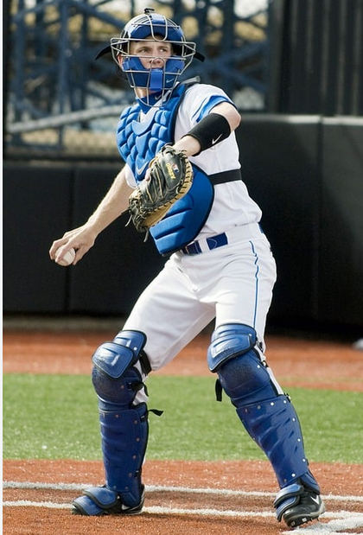

Bunt Fielding Drill (Medium): Line up catchers single file behind home plate, with the first player in line in his stance. The coach holds a ball and simulates a bunt or slow hit ball by tossing the ball in front of home plate. The catcher should spring from his stance, sprint to the ball, field, and throw to first base. Make sure to pick the ball up with a bare hand if stopped, or both hands if still chopping.
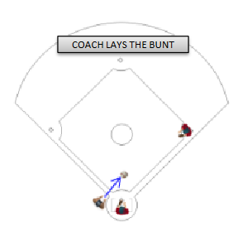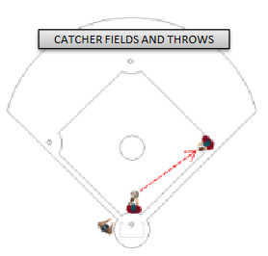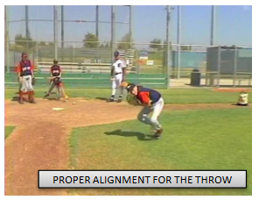
Catcher Pop Flies (Hard): Have a catcher start in their stance with glove and mask on. Coach should stand about 1 foot in front of home plate. Coach throws a pop fly and the catcher should practice taking their mask off, turning around, finding the ball and making the catch. Throw some fly balls in foul territory and some in fair. Repeat for each catcher in the group.
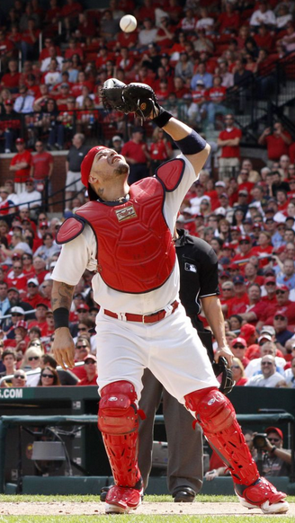

Scrimmage/Team Games:
3 Team Scrimmage (Easy): Divide teams into three groups (some groups can have 4 if needed). One group is infield, one is outfield, one is at-bat. The coach’s will act as pitcher (and catcher, if needed). The coach will pitch to the first team at bat. The infield and outfield will try to get the hitters out. The game continues until 3 outs are made (or the hitting team bats 2-3 times through). No bunting, and this is a good chance to stop the game and coach, as needed.
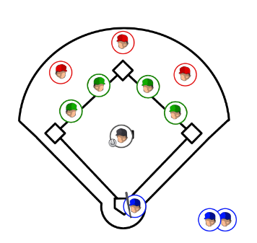
Ultimate Baseball (Medium): This is a fun game that uses baseball movements in a play environment. Divide the team into two equal groups and all players should have a glove on. Find a large grassy area (or the outfield) and create a field 60 yards wide by 30 yards wide. One team will start with a ball (use a tee ball, tennis or other soft ball). Players can move only without the ball, and must throw the ball downfield to their teammates. If a ball is dropped or deflected, it’s a turnover and the other team gets the ball and starts from there. Everytime the team gets to the endzone, it’s a point. First team to 7 points wins. Encourage short, accurate passes instead of long hail mary’s. For younger players, you can allow 2 or 3 steps after catching to help move the ball along.
