CT Baseball - Coaches Practice Playbook – Practice 5
Coaches Reminder – In addition to this practice plan, refer to the CT Baseball drill library to help customize based on the skill level of your team and desired focus areas.
Pre-Practice Huddle (5 minutes):
- Rule review – Review what happens if a ball hits a runner. If a fielder didn’t get a chance to make a play on the ball, play is dead and the runner is out. If the fielder has a chance but missed it, it’s a live ball and play continues as if the ball had hit a wall.
- Discuss what went well/not so well in recent games/practices
Warm Up/Partner Skill Building (20-25 minutes):
- Follow the CT Baseball – Suggested Warm Up Routine guidelines
Stations (30-40 minutes):
- Divide players equally into groups – suggest 3-4 stations total depending on the number of assistant coaches/parent helpers. You can also split the team into two groups and change the stations after two rotations (for a total of 4 stations).
- Station 1 – Hitting - Suggested Drill – Swing-Hold-Drop (Medium): Swing using a tee, soft toss or even dry swings. Have the player hold their finish for a 3 count. Then the batter should drop their back knee to the ground slowly. Once the knee touches the ground, lift straight back up to your finish position. If they can’t hold their finish, they have poor balance and they may need to simplify their swing.
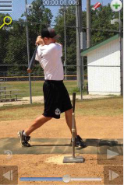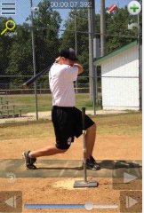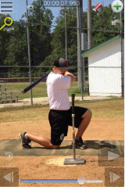
- Station 2 – Infield - Suggested Drill – Infield Slides 5 Cone Drill (Easy): This drill is to teach players to move laterally back and forth and center the ball on their body when they can. Players will line up behind the first cone. The first player will shuffle back and forth through the 5 cones, pretending to field a ball after completing the shuffle steps across each cone. Once they get the footwork down, a coach can start rolling balls to field after each cone shuffle.
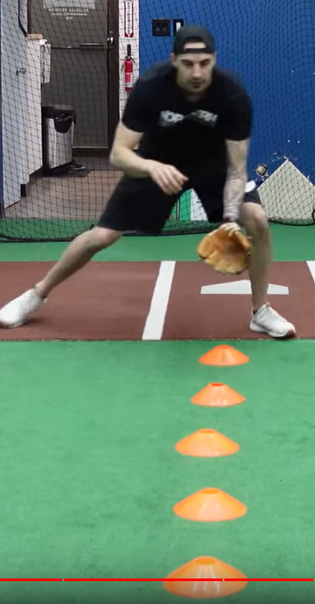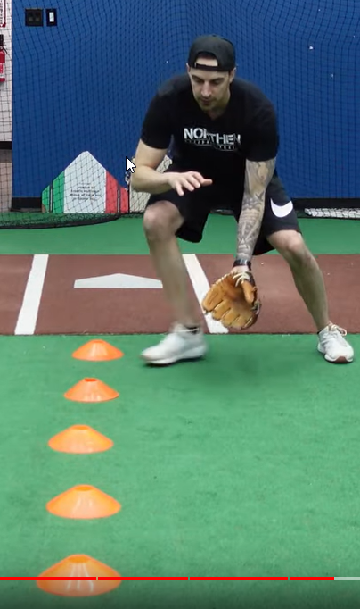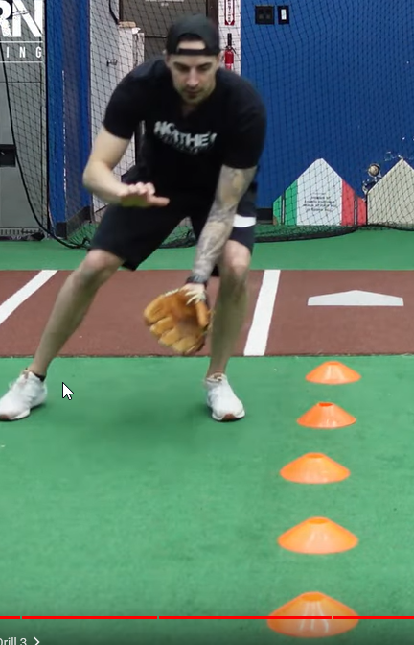
- Station 3 – Running - Suggested Drill – Slide Under the Tag (Medium): This can be set up on the infield, or in the outfield with two throw down bases. Players line up at first, coach stands about 15 feet away. Either another coach or a player stands at the second base, ready to take the throw. Allow the players to run from the first base, then time the toss to the second base so that the throw and runner arrive at almost the same time to get a tag down on the runner. Show runners the types of slides available to avoid the tag.
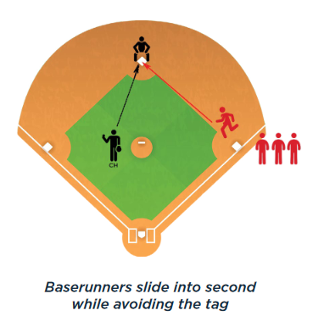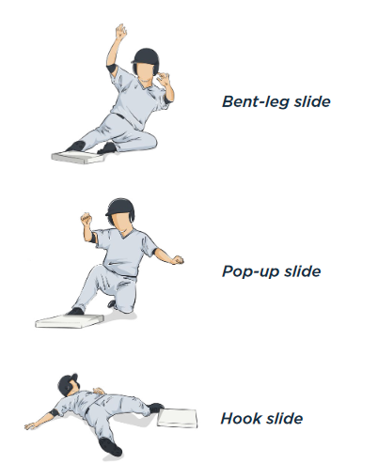
- Station 4 - (Optional) Pitching/Throwing - Suggested Drill – 21 (Easy): This is a competitive game to force players to improve their throwing accuracy under pressure. Have players pair off and stand at a comfortable throwing distance (older players move further away). The player without the ball will extend their glove towards their teammate, palm out, making a target. The thrower must hit the glove so accurately that the catching player doesn’t have to move their glove. If the player moves less than 2-3 inches the thrower gets two points. If the throw is above the waist and inside the catchers body/frame, it’s 1 point. The first partner to 21 wins. Players should work from the stretch or windup to increase formal pitching repetitions.
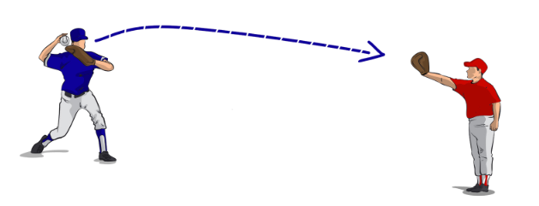
- Players will spend about 10 minutes at each station before rotating to the next
Water Break + Huddle (5-10 Minutes):
- Word of the Week – Learn from Failure
  - "I missed more than 9000 shots. 26 potential game-winners. Lost 300 games. “Failed” over and over. THAT is why I succeed!" -Michael Jordan
  - Play free – youth baseball is not a life or death affair.
  - Learn from your mistakes, one failure is an opportunity, not a permanent result
  - Grow – always learn, always improve, always look for the next thing
  - Team Building Activity of the Week – Play Simon Says!
- Team Activity (25-30 Minutes):
Suggested Drill/Fun Activity – Ultimate Baseball (Medium): This is a fun game that uses baseball movements in a play environment. Divide the team into two equal groups and all players should have a glove on. Find a large grassy area (or the outfield) and create a field 60 yards wide by 30 yards wide. One team will start with a ball (use a tee ball, tennis or other soft ball). Players can move only without the ball, and must throw the ball downfield to their teammates. If a ball is dropped or deflected, it’s a turnover and the other team gets the ball and starts from there. Every time the team gets to the endzone, it’s a point. First team to 7 points wins. Encourage short, accurate passes instead of long hail mary’s. For younger players, you can allow 2 or 3 steps after catching to help move the ball along.
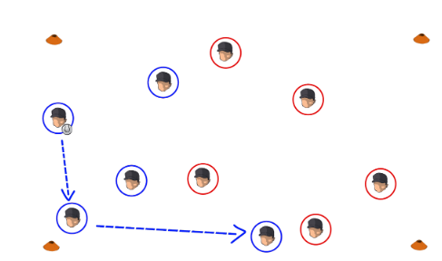

Post Game (2 minutes):
- Remind players of next upcoming practice and any details regarding schedule and uniform distribution
- Encourage teammates to practice at home with parents, guardians or friends

