CT Baseball - Coaches Practice Playbook – Practice 11
Coaches Reminder – In addition to this practice plan, refer to the CT Baseball drill library to help customize based on the skill level of your team and desired focus areas.
Pre-Practice Huddle (5 minutes):
- Rule review – Out of play balls
  - If a batted ball bounces over the fence, it’s a ground rule double
  - If a ball is thrown from the outfield, it’s 2 bases from the time of the throw (generally the base the runner is going to +1)
  - If a ball is thrown from the infield, runners are awarded 2 bases from the start of the play.
  - If a batted ball gets lodged in a fence, it’s 2 bases from the start of the play
  - If a ball thrown from the pitchers mound goes out of play or gets lodged in the fence, it’s one base for the runners
- Discuss what went well/not so well in recent games/practices
Warm Up/Partner Skill Building (20-25 minutes):
- Follow the CT Baseball – Suggested Warm Up Routine guidelines
Stations (30-40 minutes):
- Divide players equally into groups – suggest 3-4 stations total depending on the number of assistant coaches/parent helpers. You can also split the team into two groups and change the stations after two rotations (for a total of 4 stations).
- Station 1 – Hitting - Suggested Drill – Walk Throughs/Happy Gilmore’s (Hard): Begin well behind the batters box. Take a small step forward with your front foot, then step behind the front foot with your back foot, then finally stride and “walk” into your normal swing. This drill is designed to bring rhythm and timing into unloading the swing.
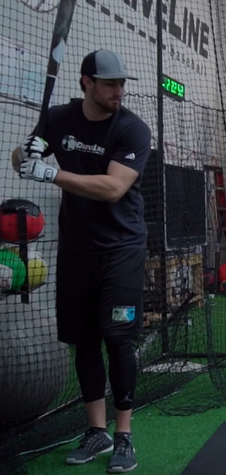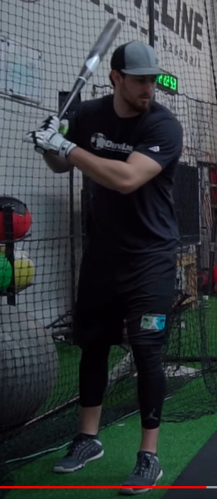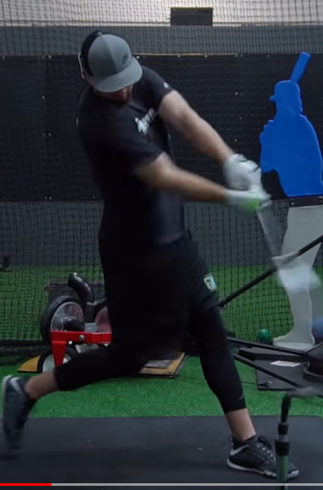
- Station 2 – Infield - Suggested Drill – Infield Knockout (Easy): Players spread out in the infield (or form lines). A coach will stand at home plate with a bat and bucket of balls. Either a coach or a player will play first base (suggest a coach for younger teams). The coach will hit groundballs towards a player in the infield, the player must field the ball cleanly and throw to first base. If the player makes a mistake fielding or throwing, they are “out.” The coach continues until all but one player has been eliminated - that player is the survivor and winner. You can give 3 lives for younger players to get more opportunities. A variant of this knockout game is called “guts,” where the coach hits a soft ball very hard at the players, and they are only “out” if the ball gets behind them.
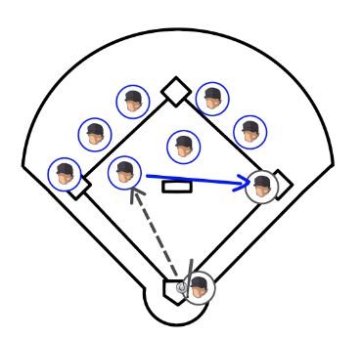
- Station 3 – Catching - Suggested Drill – Bunt Fielding Drill (Medium): Line up catchers single file behind home plate, with the first player in line in his stance. The coach holds a ball and simulates a bunt or slow hit ball by tossing the ball in front of home plate. The catcher should spring from his stance, sprint to the ball, field, and throw to first base. Make sure to pick the ball up with a bare hand if stopped, or both hands if still chopping. This is a good drill for young players too, so they know to go get slowly hit balls from the catcher position.
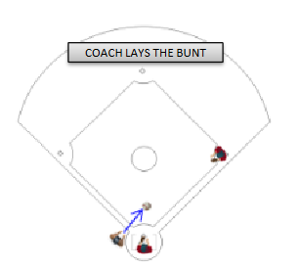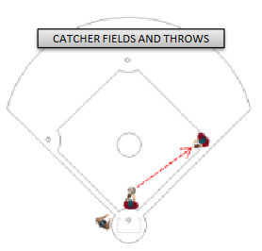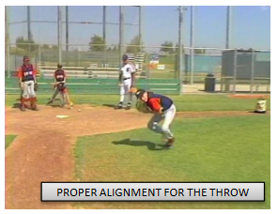
- Station 4 - (Optional) Pitching - Balance, Power, Finish (Easy): The purpose of this drill is to establish balance at three crucial stages of the delivery. This drill is typically done with partners, gloves on, and a baseball for each set of partners. Have the pitchers begin by lifting their stride leg and balancing with their leg up for several seconds. Coaches can even gently push the players leg and see if they can maintain their balance. Next, have the player separate their hands and stride, with throwing arm back and glove hand tucked, pointed towards the target in the power position. Have the player pause in the power position and check for balance and arm/leg position. Finally, have the player finish their delivery in a follow through, with balance on their stride foot and prepared to field the baseball. Note that pitchers that throw with good velocity tend to “fly open” and spin off towards first base (right hander) or third base (left hander). This is acceptable and necessary to generate velocity, but for many youth pitchers it’s important to teach balance to improve thrown accuracy and provides the pitcher with the ability to protect themselves when a ball is hit to them.
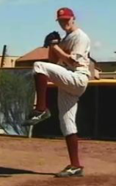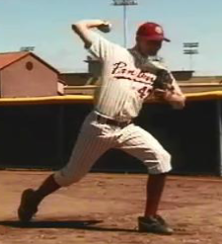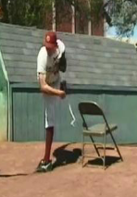
Players will spend about 10 minutes at each station before rotating to the next
Water Break + Huddle (5-10 Minutes):
- Word of the Week – Focus
  - “Lock in! Watch, listen, think…. Right here, right now.”
  - Instead of just listening, hear, understand and clarify if needed. Try to understand the why and how behind everything we do at practice.
  - In order to be successful, you need to have the ability to focus on a task very closely – it’s hard to hit or catch a tiny baseball flying at you very quickly!
  - Team Building Activity of the Week – “Show us your focus! We’re going to play the game I spy!” Each coach gets a turn to pick the object, and kids try to guess it.
- Team Activity (25-30 Minutes):
Suggested Drill - Progressive Tag Up (Medium): Put 3 or 4 fielders in the outfield, and players at first, second, short, third and catcher in the infield. Remaining players line up at first. Coach will hit or throw a ball in the air to an outfielder. Runners will practice taking a lead, assessing if the outfielder is going to catch it, and either returning to the base or running to second if the ball drops. Once the runner reaches second, you can practice tag ups with runners on first and second. The runner on second can tag up and go to third at their descretion. Set up again with bases loaded.
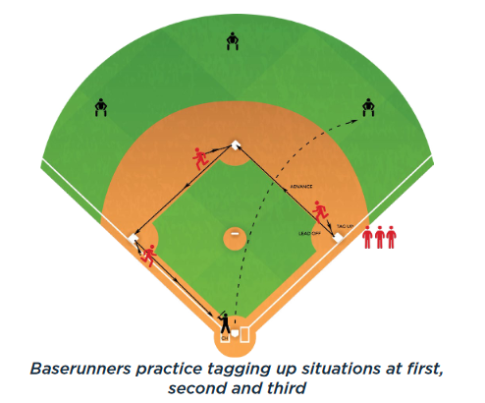
Fun Activity – 3 Swing Batting Practice – Have players take batting practice. They only get 3 swings per round. The scoring system is as follows: 3 points – line drive or deep hit into the outfield, 2 points - hard hit ball on the ground, 1 point – weakly hit ball, 0 – swing and miss. If a player scores 3 points on each, he gets a bonus point for a maximum score of 10.
Post Game (2 minutes):
- Remind players of next upcoming practice and any details regarding schedule
- Encourage teammates to practice at home with parents, guardians or friends

