CT Baseball - Coaches Practice Playbook – Practice 8

Coaches Reminder – In addition to this practice plan, refer to the CT Baseball drill library to help customize based on the skill level of your team and desired focus areas.

Pre-Practice Huddle (5 minutes):

* Rule review – The batters box. If a player makes contact with a ball and his foot is completely outside of the box, the batter is out! Remind them that you can’t step “out of the bucket” or stride onto home plate when swinging.
* Discuss what went well/not so well in recent games/practices

Warm Up/Partner Skill Building (20-25 minutes):

* Follow the CT Baseball – Suggested Warm Up Routine guidelines

Stations (30-40 minutes):

* Divide players equally into groups – suggest 3-4 stations total depending on the number of assistant coaches/parent helpers. You can also split the team into two groups and change the stations after two rotations (for a total of 4 stations).
* Station 1 – Hitting - Suggested Drill – Step Back and Gather Drill (Medium): Using a tee, start with feet together and have the ball lined up with your belly button. Hands are relaxed, bat on shoulder. Now, step back with back foot, load hands back and swing. This will emphasize back leg load and keeping the hands back prior to triggering the swing.

Station 2 – Infield - Suggested Drill – Foot replacement 4 Cone Drill (Easy): This drill is to teach proper transition from fielding to throwing, with the feet moving to turn the shoulder to the throwing target. Set up four cones in a square. The players will start in a line and pretend to field a ball in the center of their body at the first two cones, then pivot and replace their feet to turn facing the next two lines in the square. They will repeat until they return to the first position in the square. The next player will then repeat the drill all the way around the square.

Once they complete the circuit a few times, have a coach hit ground balls and practice the same foot work.

* Station 3 – Outfield - Suggested Drill – Fence Fly (Hard): Players form a line about 10 feet from a fence with gloves on. Coach has a bucket of balls and stands 20-30 feet from the line. Coach throws high arching balls designed to land between the fence and the player. The player needs to find the fence, then catch the ball. When the ball is caught, the fielder throws the ball back to the coach and the next player in line steps up.

* Station 4 - (Optional) Pitching/Throwing - Suggested Drill – Upward Tosses + High Five Upward Tosses (Easy): Holding the ball in your throwing hand with arm out to the side and forward, throw the ball up and catch it as it begins to fall. This is a natural arm slot and this drill trains the arm to find that natural L position. This will also build strength in the arm.

High Five (Easy): This drill focuses on a powerful follow through. The pitcher will get into the power position with stride foot down and arms in the “T” position. The coach will kneel down and high five the player. The pitcher will then simulate completing his follow through against the resistance provided by the coach. No baseball is required for this drill.

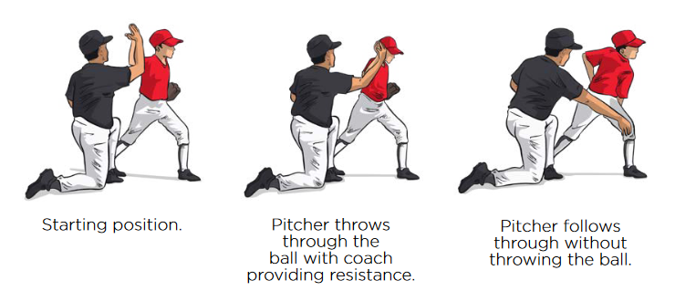

* Players will spend about 10 minutes at each station before rotating to the next

Water Break + Huddle (5-10 Minutes):

* Word of the Week – Effort
  + Attitude and effort never have slumps
  + A great attitude (desire to win and get better, looking forward to the next play) naturally makes it easier to play harder and make more of an effort
  + Have fun and remember to play with effort and intensity when you’re out there.
  + Team Building Activity of the Week – Show your effort and intensity to the task by seeing who can go the longest without blinking! (coaches judge)
* Team Activity (25-30 Minutes):

Suggested Drill - Around the Horn Baserunning (Medium): Split your players into two teams. One team lines up at home plate as baserunners, the second team plays the infield (outfielders optional as backups). Coach hits the ball to an infielder. The fielder throws to first base, then to second, then third, and finally home. At the same time the ball is hit, the runner leaves from home and attempts to make it all the way around the bases before the fielders get the ball back to home. The winner is whoever gets to home first.

Fun Activity – Catch-Pivot-Throw Relay (Easy): Line up players in a line with gloves. One player at the end has a ball. When the coach says “go” the player with the ball will throw to the next player in line. The player will step to the ball, pivot on his back foot, and complete the throw to the next player in line. Continue until the ball has made it to the end and then back to the first player. You can either time the drill, or play as teams to make it more competitive. If the kids haven’t seen the pivot footwork before, show them it in slow motion first.

Post Game (2 minutes):

* Remind players of next upcoming practice and any details regarding schedule
* Encourage teammates to practice at home with parents, guardians or friends